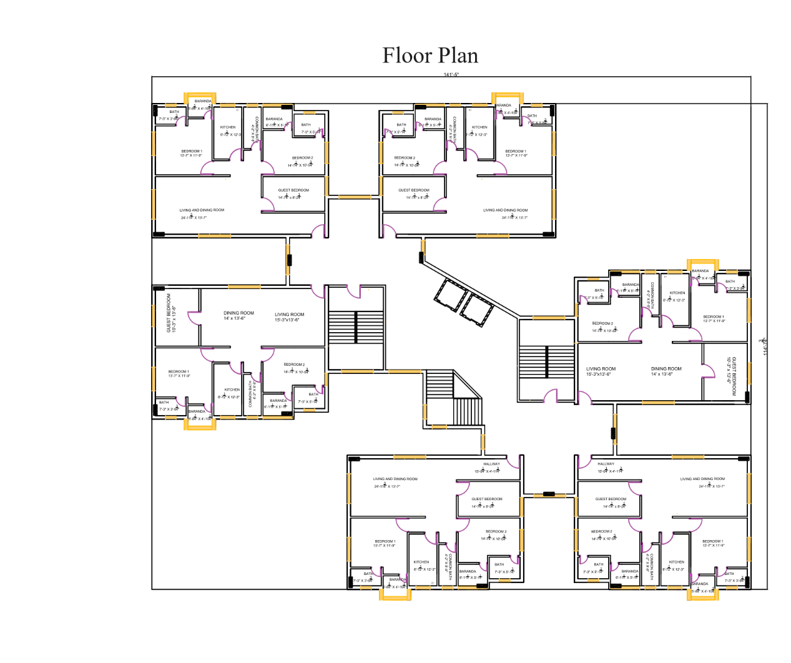**jhfvjyhfyhv**

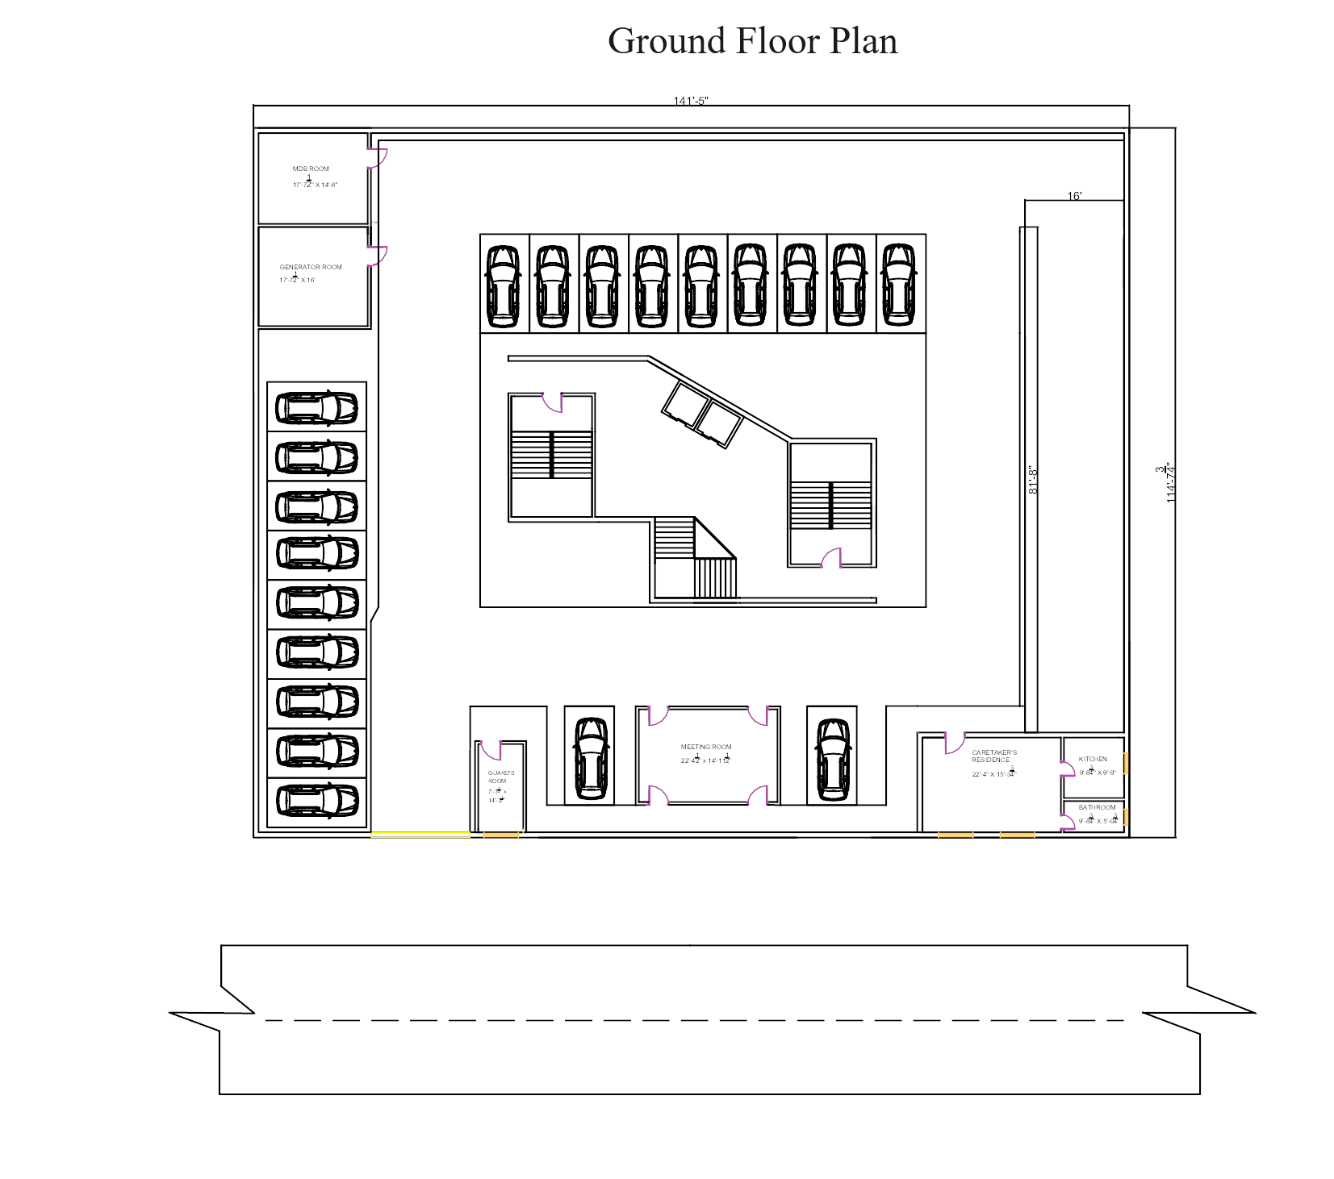

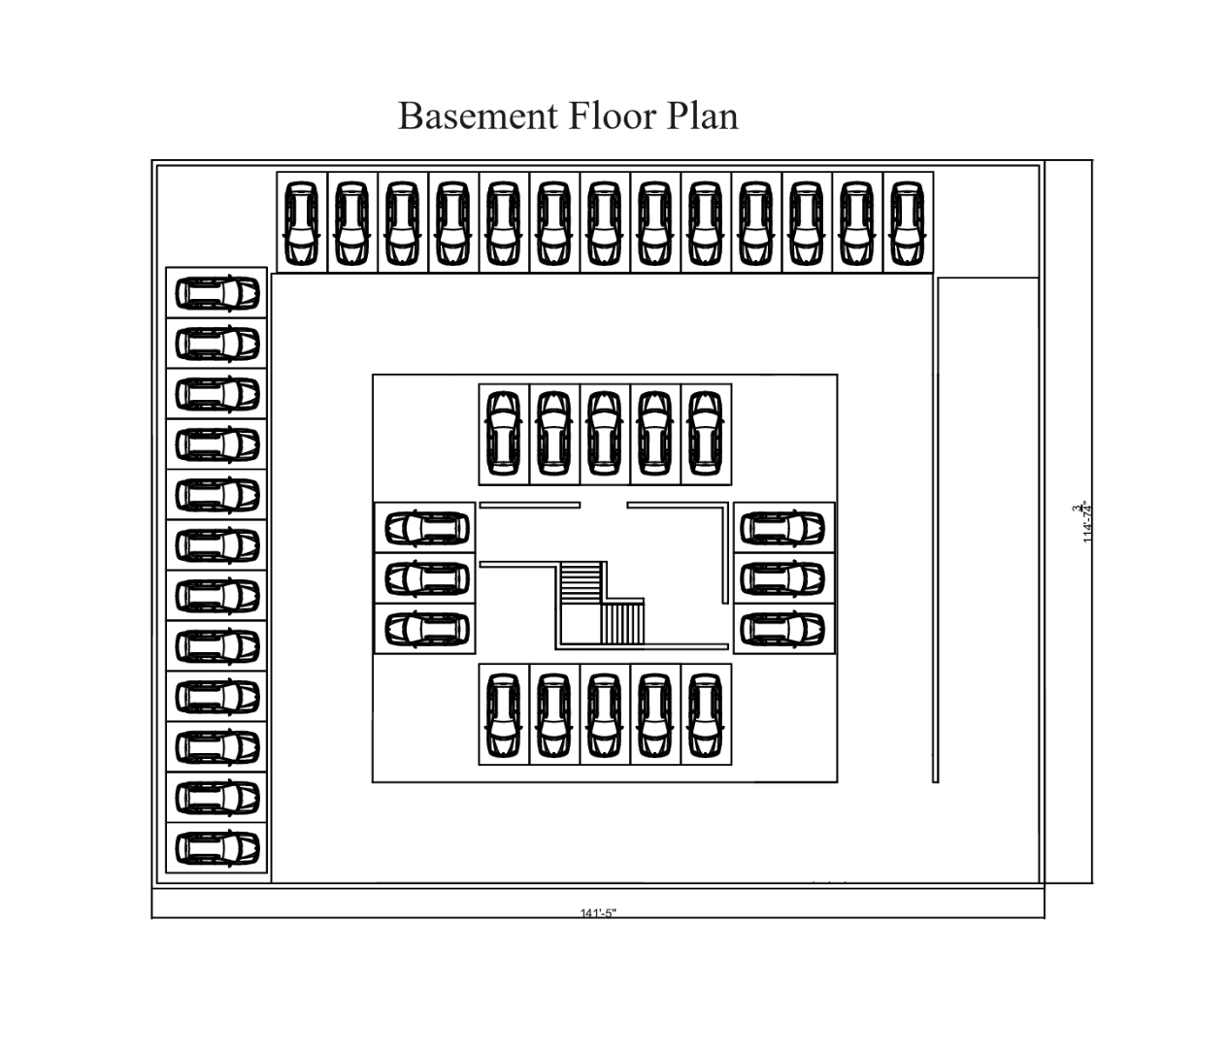

**Calculations for**

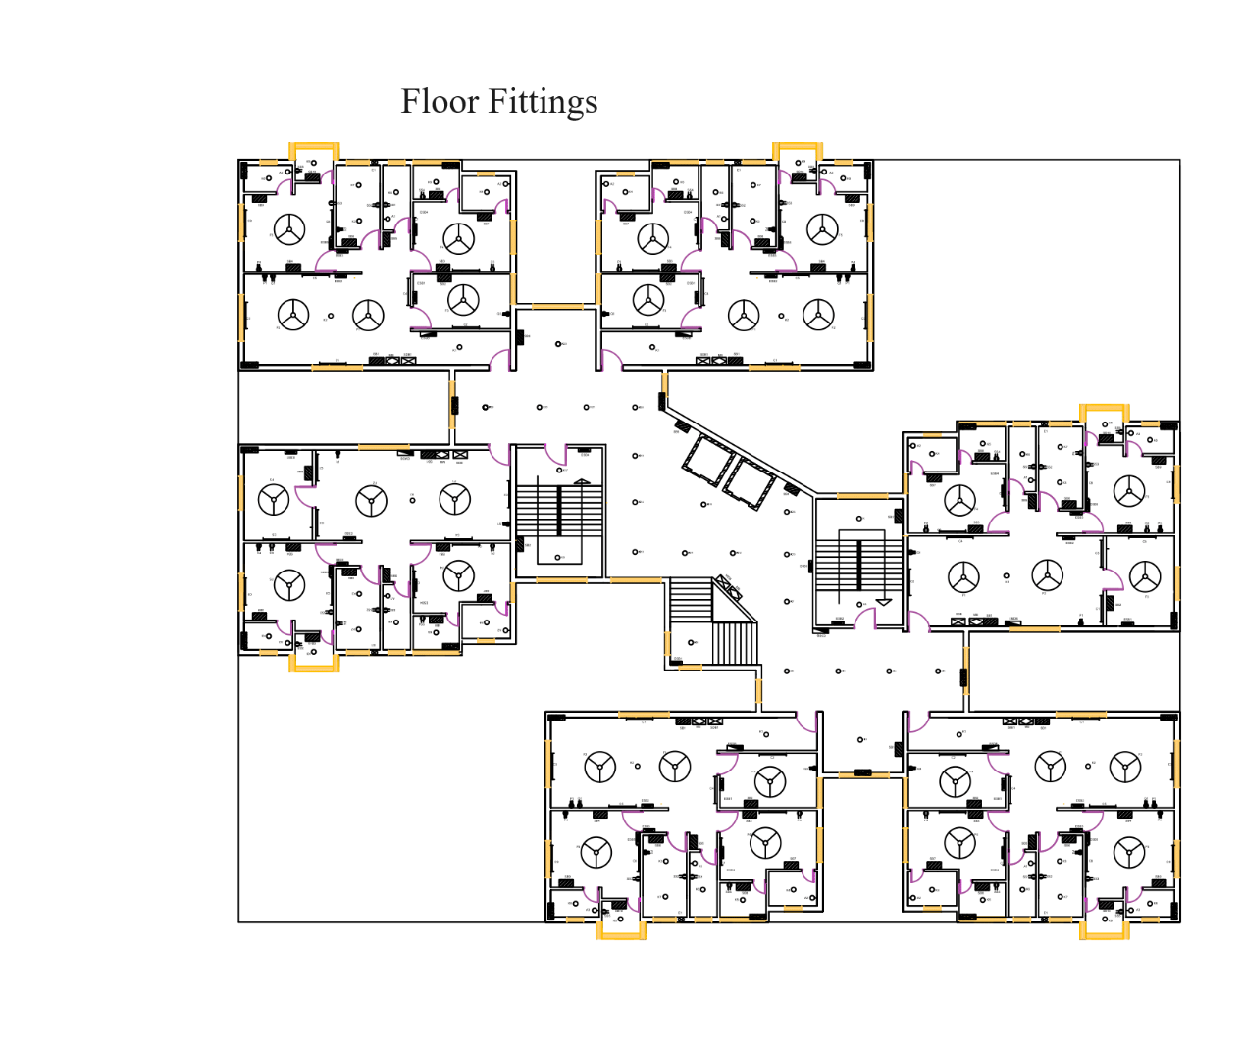

**Flat type 1 and flat type 2:**

**Flat 1:**

Formula for number of light fittings in the space , N = $\frac{E * A (in sq m)}{n * LLF * UF}$

Formula for number of fans in the space, N = $\frac{A (in sq ft)}{100}$

**Calculations for living and dining space:**

Area of the space, A = 326.029788 sq. ft = 30.2891584 sq. m

Recommended illumination, E= 100 lux

Light loss factor and utilization factor , LLF X UF = 0.7

Flux of one light source, F = 1250 lumen

Number of light sources per fitting, n = 1

Number of light fittings, N = 3.46 =~ 4

Number of fans, N = 3.26 =~ 3

From intuition, we used 5 lights in this space (4 tube lights of 22 W and one ceiling light of 20 W). We also settled on 2 fans, one for the dining space and one for the living room space.

**Calculations for hallway:**

Area of the space, A = 60.116 sq. ft = 5.584984 sq. m

Recommended illumination, E= 100 lux

Light loss factor and utilization factor , LLF X UF = 0.7

Flux of one light source, F = 1250 lumen

Number of light sources per fitting, n = 1

Number of light fittings, N = 0.638 =~ 1

Number of fans, N = 0.60116 =~ 0

From intuition, we used 1 light of one ceiling light of 20 W in this space. We also settled on no fans, since this is not a space for anyone to reside in.

**Calculations for guest bedroom:**

Area of the space, A = 112.0576 sq. ft = 10.4104939 sq. m

Recommended illumination, E= 100 lux

Light loss factor and utilization factor , LLF X UF = 0.7

Flux of one light source, F = 1250 lumen

Number of light sources per fitting, n = 1

Number of light fittings, N = 1.189 =~ 1

Number of fans, N = 1.12 =~ 1

From intuition, we used 1 light in this space (1 tube light of 22 W). We also settled on 1 fan.

**Calculations for bedroom 1:**

Area of the space, A = 1567.939sq. ft = 15.602057 sq. m

Recommended illumination, E= 100 lux

Light loss factor and utilization factor , LLF X UF = 0.7

Flux of one light source, F = 1250 lumen

Number of light sources per fitting, n = 1

Number of light fittings, N = 1.783 =~ 2

Number of fans, N = 31.679 =~ 1

From intuition, we used 2 lights in this space (2 tube lights of 22 W). We also settled on 1 fan.

**Calculations for bedroom 2:**

Area of the space, A = 150.077299 sq. ft = 13.942637 sq. m

Recommended illumination, E= 100 lux

Light loss factor and utilization factor , LLF X UF = 0.7

Flux of one light source, F = 1250 lumen

Number of light sources per fitting, n = 1

Number of light fittings, N = 1.59344 =~ 2

Number of fans, N = 1.5 =~ 1

From intuition, we used 2 lights in this space (2 tube lights of 22 W). We also settled on 1 fan.

**Calculations for bathroom 1:**

Area of the space, A = 21.76928191 sq. ft = 2.022432468056 sq. m

Recommended illumination, E= 100 lux

Light loss factor and utilization factor , LLF X UF = 0.7

Flux of one light source, F = 1250 lumen

Number of light sources per fitting, n = 1

Number of light fittings, N = 0.2311351 =~ 1

Number of fans, N = 0.21 =~0

From intuition, we used 2 lights in this space (1 ceiling light of 20 W and one lightbulb over a supposed mirror positioning).

**Calculations for bathroom 2:**

Area of the space, A = 36.29315476 sq. ft = 3.371444083945 sq. m

Recommended illumination, E= 100 lux

Light loss factor and utilization factor , LLF X UF = 0.7

Flux of one light source, F = 1250 lumen

Number of light sources per fitting, n = 1

Number of light fittings, N = 1.59344 =~ 2

Number of fans, N = 1.5 =~ 1

From intuition, we used 2 lights in this space (1 ceiling light of 20 W and one lightbulb over a supposed mirror positioning).

**Calculations for common bathroom:**

Area of the space, A = 40.625 sq. ft = 3.774186 sq. m

Recommended illumination, E= 100 lux

Light loss factor and utilization factor , LLF X UF = 0.7

Flux of one light source, F = 1250 lumen

Number of light sources per fitting, n = 1

Number of light fittings, N = 0.43133 =~ 1

Number of fans, N = 0.4 =~ 0

From intuition, we used 2 lights in this space (1 ceiling light of 20 W and one lightbulb over a supposed mirror positioning).

**Calculations for kitchen:**

Area of the space, A = 73.51417824 sq. ft = 6.829 sq. m

Recommended illumination, E= 200 lux

Light loss factor and utilization factor , LLF X UF = 0.7

Flux of one light source, F = 1250 lumen

Number of light sources per fitting, n = 1

Number of light fittings, N = 1.57006 =~ 2

Number of fans, N = 0.735141 =~ 0

From intuition, we used 2 lights in this space (2 ceiling lights of 20 W).

**Calculations for baranda 1:**

Area of the space, A =

Number of light fittings, N =~ 1

Number of fans, N = 0

From intuition, we used 1 lights in this space ((1 ceiling light of 20 W).

**Calculations for baranda 2:**

Area of the space, A =

Number of light fittings, N =~ 1

Number of fans, N = 0

From intuition, we used 1 lights in this space ((1 ceiling light of 20 W).

**Flat 2:**

Most of flat 1 and flat 2 have similar features, except that flat 1 lacks the hallway and the dining, living rooms, and guest bedroom are slightly different.

**Calculations for living and dining space:**

Area of the space, A = 395.55 sq. ft = 36.68508792 sq. m

Recommended illumination, E= 100 lux

Light loss factor and utilization factor , LLF X UF = 0.7

Flux of one light source, F = 1250 lumen

Number of light sources per fitting, n = 1

Number of light fittings, N = 4.19 =~ 4

Number of fans, N = 3.94 =~ 3

From intuition, we used 5 lights in this space (4 tube lights of 22 W and one ceiling light of 20 W). We also settled on 2 fans, one for the dining space and one for the living room space.

**Calculations for guest bedroom:**

Area of the space, A = 138.375 sq. ft = 12.85545816 sq. m

Recommended illumination, E= 100 lux

Light loss factor and utilization factor , LLF X UF = 0.7

Flux of one light source, F = 1250 lumen

Number of light sources per fitting, n = 1

Number of light fittings, N = 1.46 =~ 1

Number of fans, N = 1.38 =~ 1

From intuition, we used 1 light in this space (1 tube light of 22 W). We also settled on 1 fan.

**Lobby:**

We decided on placing several lights in the lobby area.

The entire area of the lobby, A= 173.5528 sq. m

Recommended illumination, E= 70 lux

No of lights to be added here = 19.78603

Intuitively, we added about 19 lights in this space, ceiling lights of 20 W.

**Staircases:**

This is for the emergency staircase:

The area of the staircase landing, A= 6.9445 sq. m

Recommended illumination, E= 100 lux

No of lights to be added here = 0.7936 =~1

Intuitively, we added about 1 light in each stair landing, ceiling light of 20 W.

This is for the staircases that are used normally:

The area of the staircase landing, A= 7.548322 sq. m

Recommended illumination, E= 100 lux

No of lights to be added here =~1

Intuitively, we added about 1 light in each stair landing, ceiling light of 20 W.

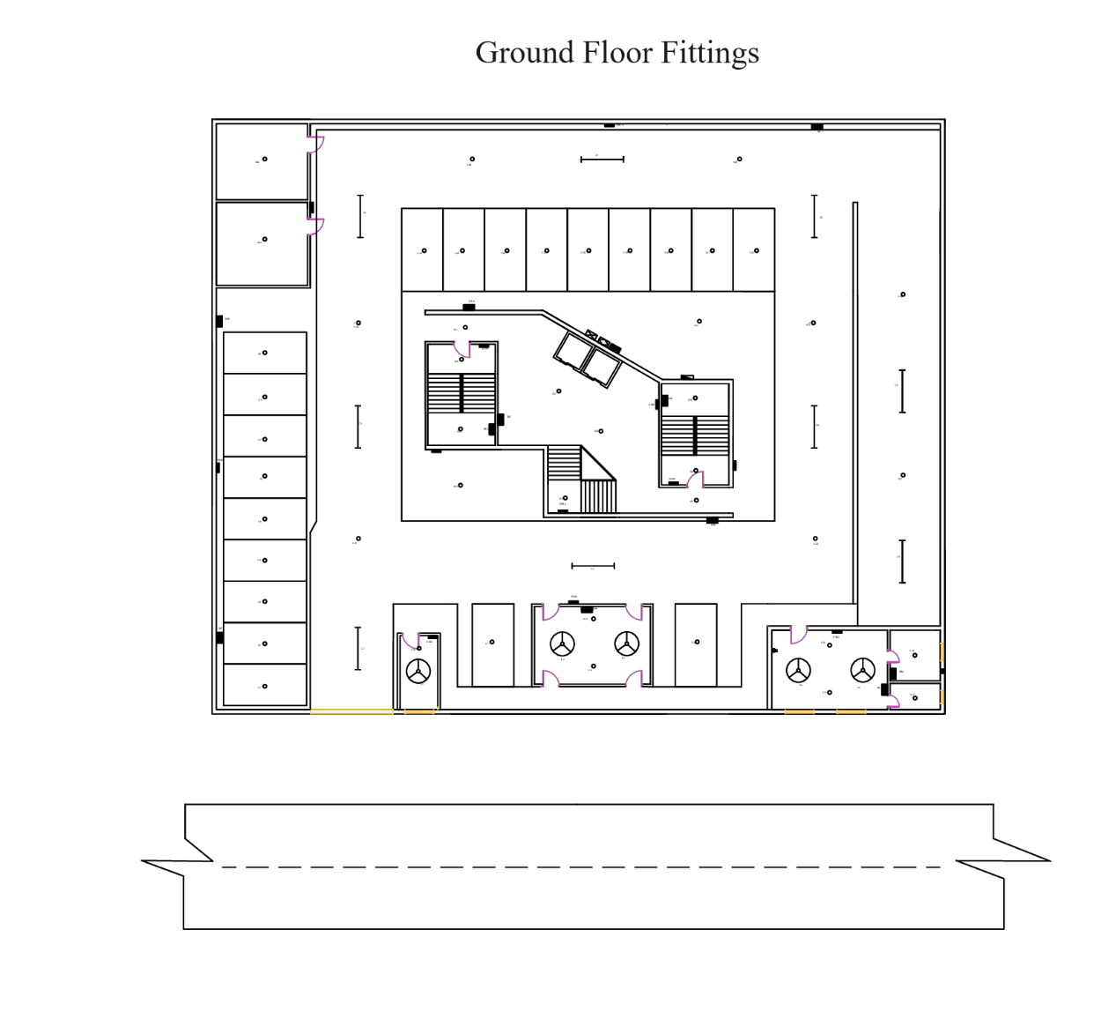

**Fittings Calculations for Ground floor:**

**Calculations for meeting room:**

The area of the meeting room, A= 31.1 sq. m = 334.50625 sq ft

Recommended illumination, E= 50 lux

No of lights to be added here = 1.77 =~ 2

Number of fans, N = 3.34 =~ 3

Intuitively, we added about 2 lights in this space, ceiling lights of 20 W. Instead of adding 3 fans, we added 2 about the center of the room.

**Calculations for caretaker’s living quarters:**

The area of the caretakers’ residence , A= 31.1 sq. m = 335.232 sq ft

Recommended illumination, E= 100 lux

No of lights to be added here = 3.55 =~ 3

Number of fans, N = 3.35 =~ 3

Intuitively, we added about 2 lights in this space, ceiling lights of 20 W. Instead of adding 3 fans, we added 2 about the center of the room

The area of the caretakers’ kitchen , A= 8.18 sq. m = 88.09 sq ft

Recommended illumination, E= 200 lux

No of lights to be added here = 1.36 =~ 1

We added about one light in this space, ceiling light of 20 W. We added 1 exhaust fan.

The area of the caretakers’ bathroom, A = 4.23 sq. m = 45.5775 sq ft

Recommended illumination, E= 100 lux

No of lights to be added here = 0.48 =~ 1

We added about one light in this space, ceiling light of 20 W.

**Calculations for watchman’s room:**

The area of the watchman’s room, A = 9.109 sq. m = 98.0525 sq ft

Recommended illumination, E= 50 lux

No of lights to be added here = 0.52 =~ 1

Number of fans, N = 0.98 =~ 1

We added about one light in this space, ceiling light of 20 W. We also added a ceiling fan.

**Calculations for generator room:**

The area of the generator room, A = 25.2696 sq. m = 272 sq ft

Recommended illumination, E= 50 lux

No of lights to be added here = 1.44 =~ 1

We added about one ceiling light of 20 W in this space.

**Calculations for watchman’s room:**

The area of the MDB room, A = 23.16 sq. m = 249.33 sq ft

Recommended illumination, E= 50 lux

No of lights to be added here = 1.32 =~ 1

We added about one ceiling light of 20 W in this space.

**Calculations for ground parking area (including downward ramp and lobby space):**

Area of the space, A = 1299.876 sq. m

Recommended illumination for parking space, E= 70 lux

Light loss factor and utilization factor , LLF X UF = 0.7

Flux of one light source, F = 1250 lumen

Number of light sources per fitting, n = 1

Number of light fittings, N = 103.99 =~104

From intuition, we used 44 lights in this space (9 tube lights of 22 W and 35 ceiling light of 20 W). Since it will only be used for car parking, we reduced the recommended number of lights.

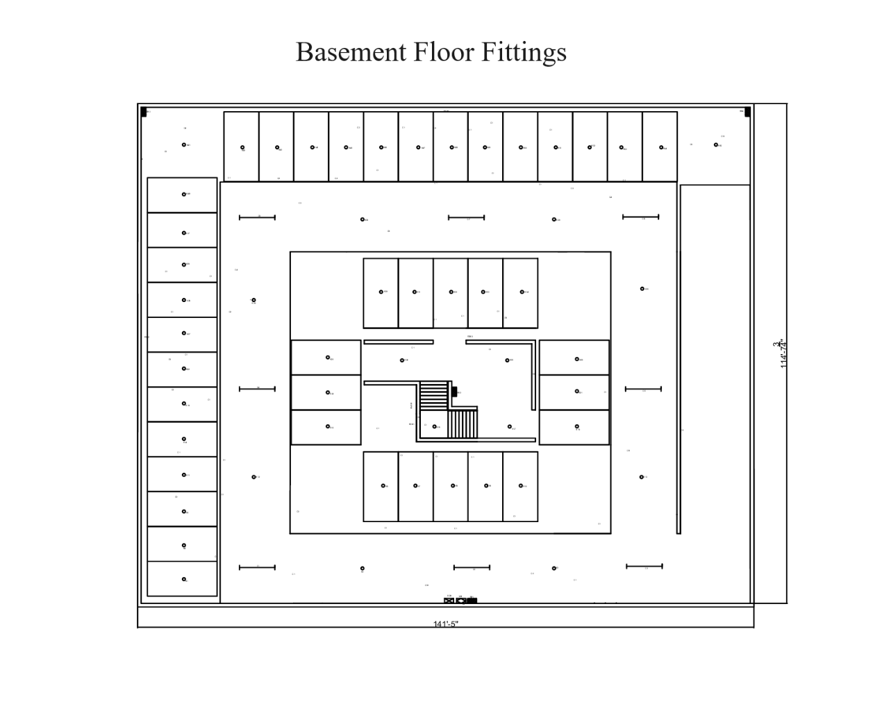

**Fittings Calculation for Basement:**

**Calculations for basement parking area:**

Area of the space, A = 13545.31351 sq. ft = 1258.4 sq. m

Recommended illumination for parking space, E= 70 lux

Light loss factor and utilization factor , LLF X UF = 0.7

Flux of one light source, F = 1250 lumen

Number of light sources per fitting, n = 1

Number of light fittings, N = 100.672 =~100

From intuition, we used 59 lights in this space (8 tube lights of 22 W and 51 ceiling light of 20 W). Since it will only be used for car parking, we reduced the recommended number of lights.

**Calculations for staircase:**

This is for the emergency staircase:

The area of the staircase landing, A= 6.9445 sq. m

Recommended illumination, E= 100 lux

No of lights to be added here = 0.7936 =~1

Intuitively, we added about 1 light in each stair landing, ceiling light of 20 W.

**Calculations for the lobby area:**

The area of the basement lobby, A = 67.061 sq. m

Recommended illumination, E= 70 lux

No of lights to be added here = 5.36488 =~5

Intuitively, we added about 3 ceiling lights of 20 W.

**Schedule of Conduit:**

|  |  |  |
| --- | --- | --- |
| Symbol | Containing Power Cable + ECC | Conduit Size |
| C1 | 2 x 1.5 mm2BYM + 1.5mm2 BYA | 16mm |
| C2 | 4 x 1.5 mm2 BYM + 1.5mm2 BYA | 20mm |
| C3 | 6 x 1.5 mm2 BYM + 1.5mm2 BYA | 25mm |
| C4 | 8 x 1.5 mm2 BYM + 1.5mm2 BYA | 30mm |
| C5 | 10 x 1.5 mm2 BYM + 1.5mm2 BYA | 30mm |
| C6 | 2 x 2.5 mm2 BYM + 2.5mm2 BYA | 16mm |
| C7 | 4 x 2.5 mm2 BYM + 2.5mm2 BYA | 30mm |
| C8 | 2 x 4 mm2BYM + 4mm2 BYA | 20mm |
| C9 | 12 x 1.5 mm2 BYM + 1.5mm2 BYA | 30mm |
| C10 | 6 x 2.5 mm2 BYM + 2.5mm2 BYA | 45mm |

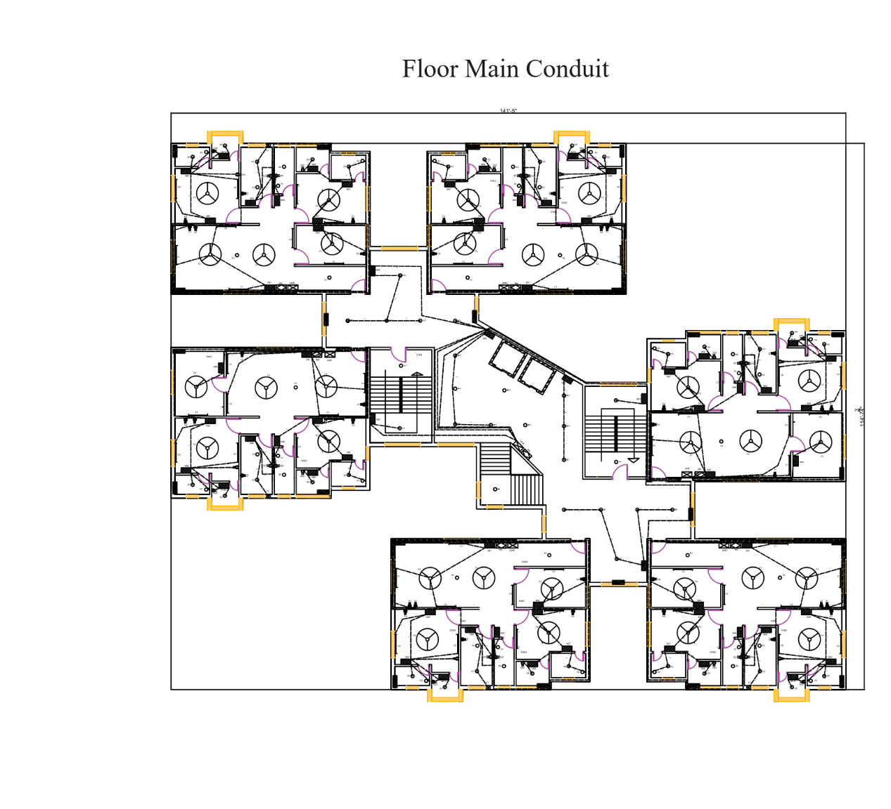

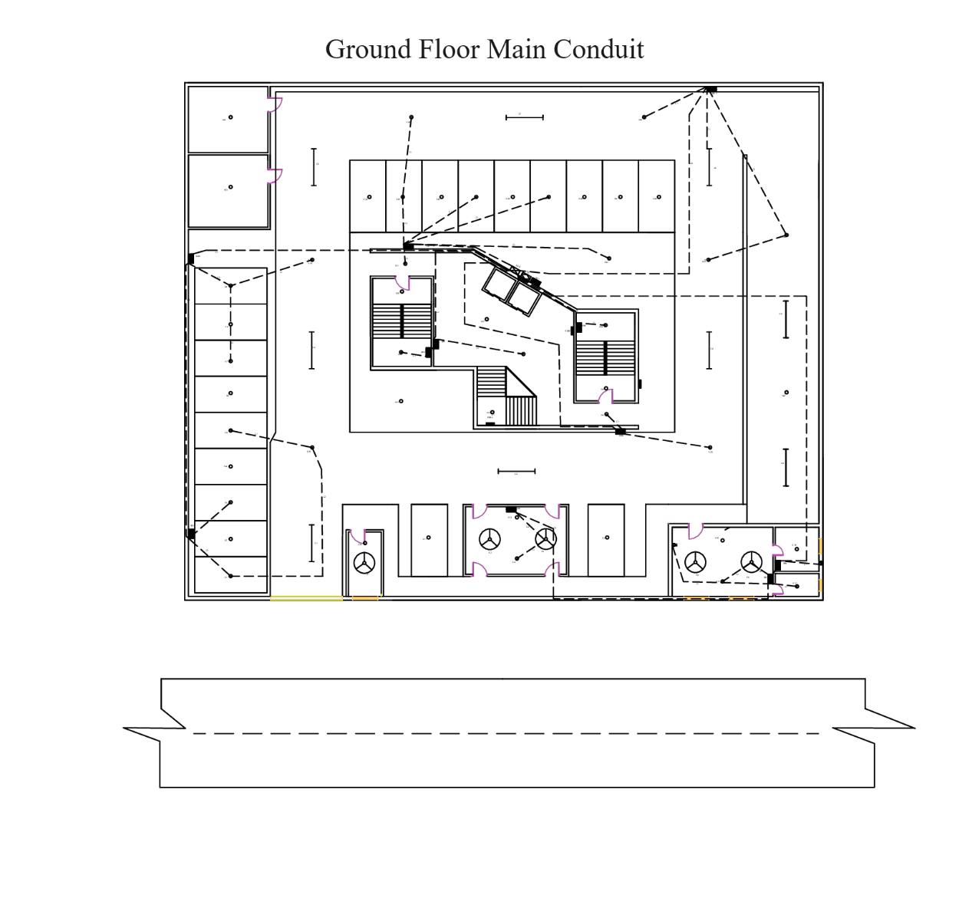

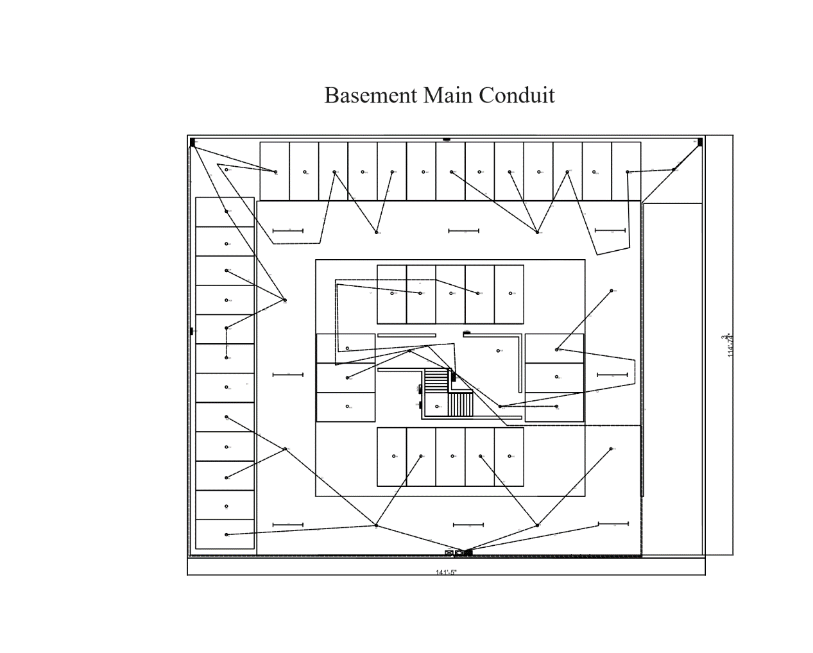

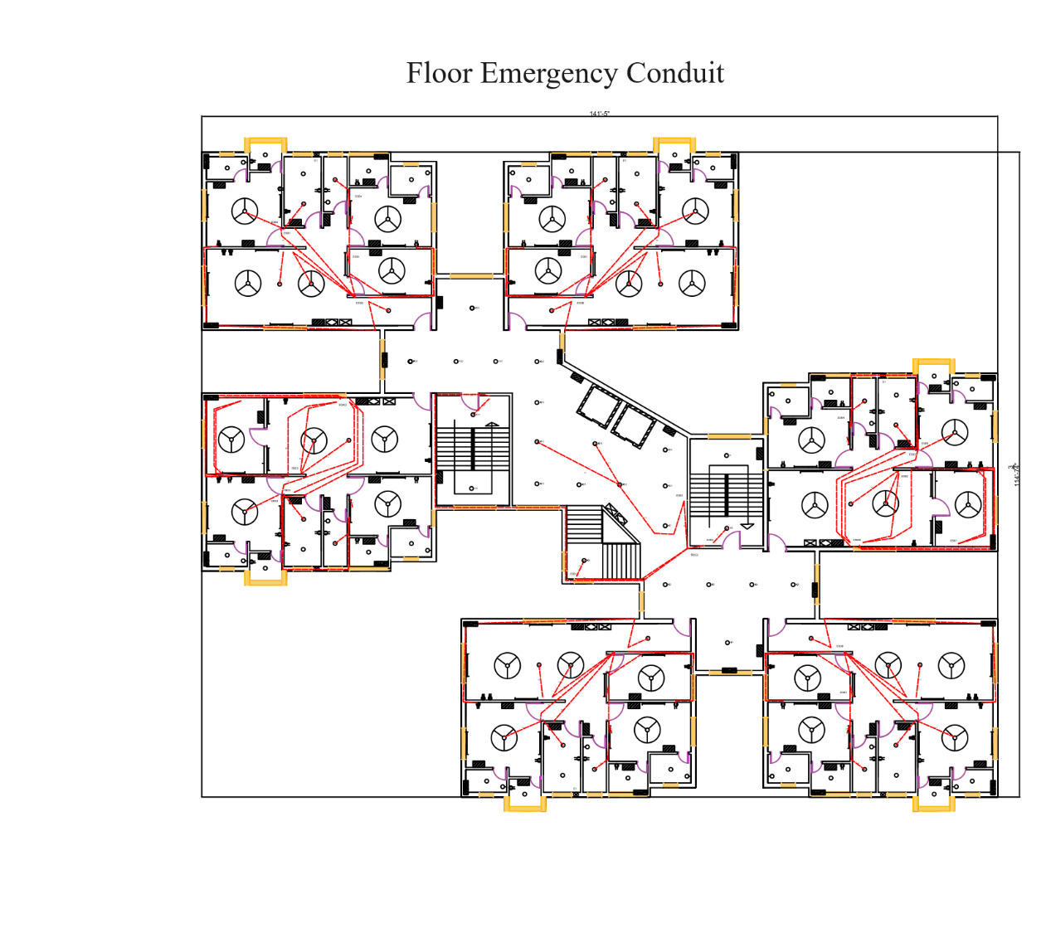

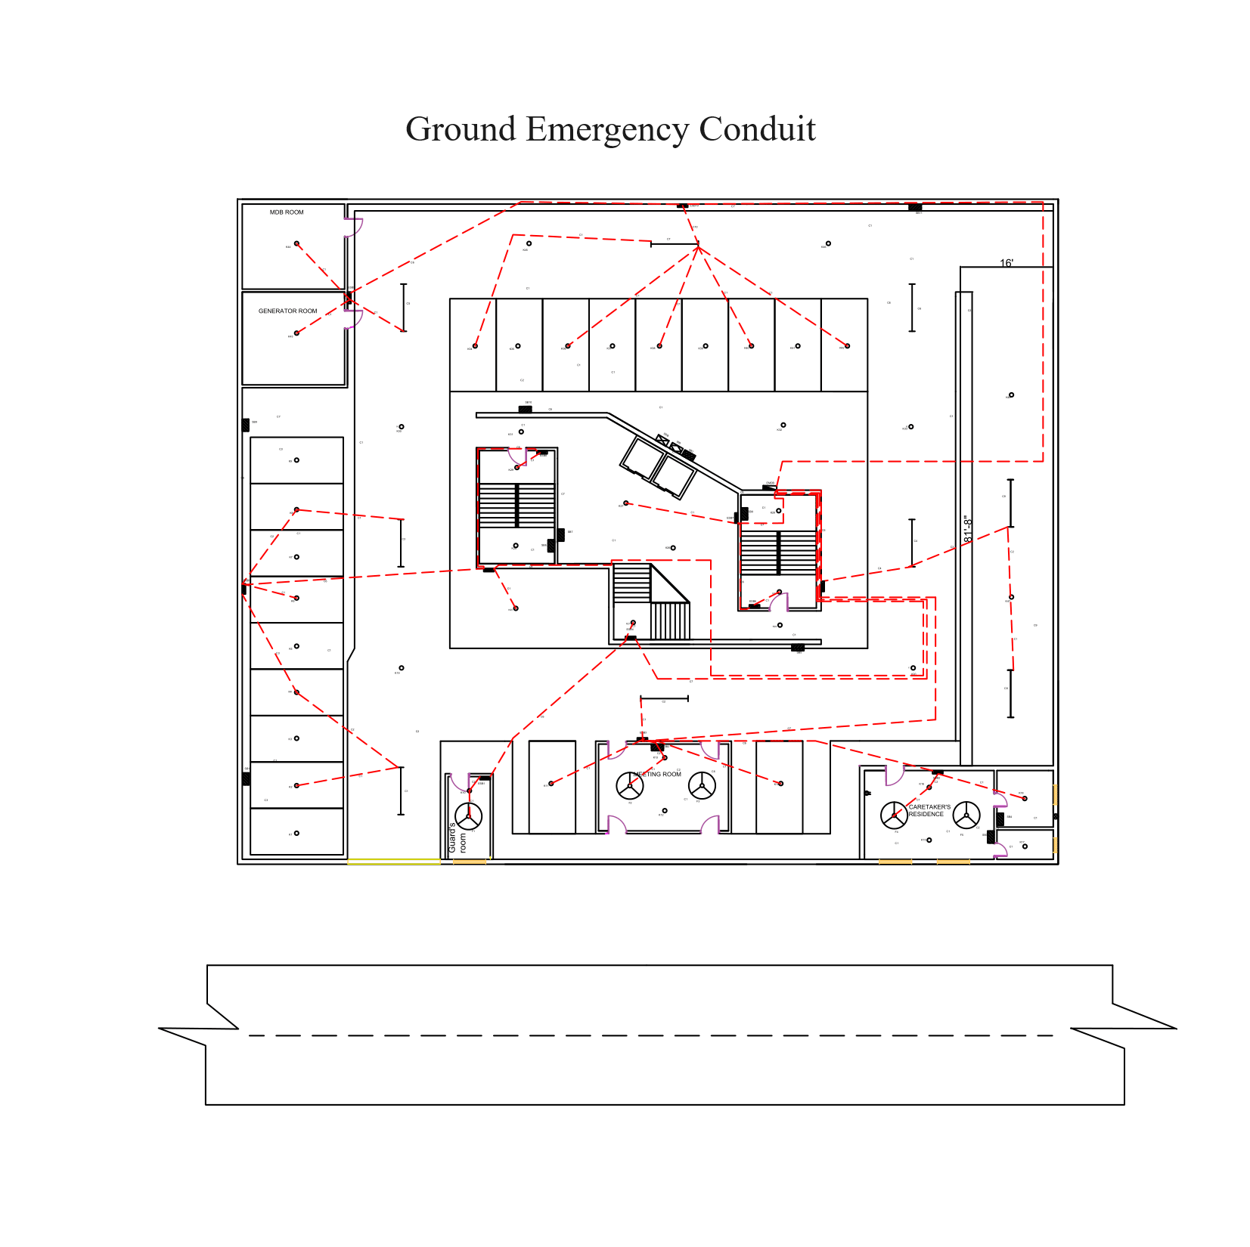

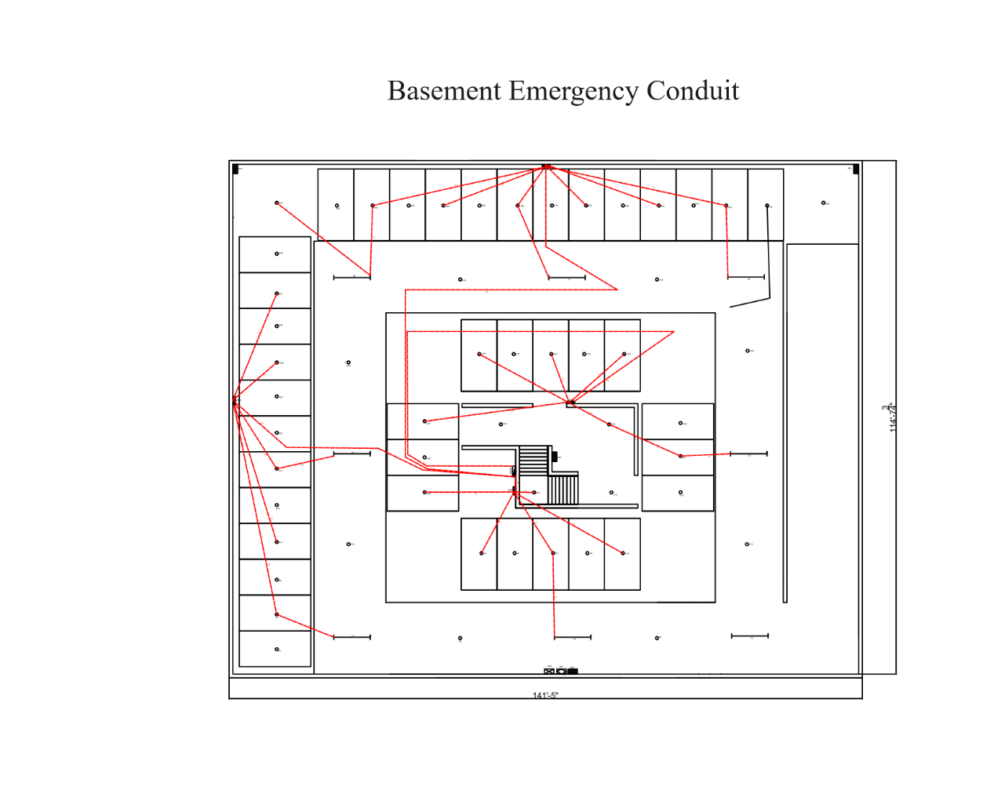

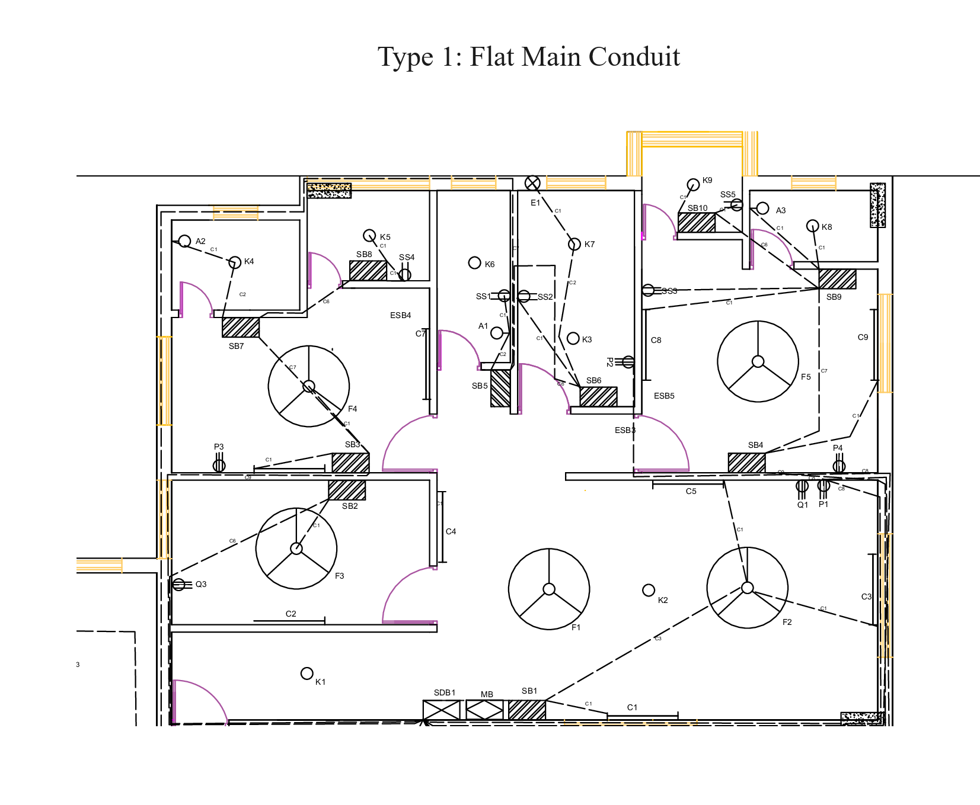

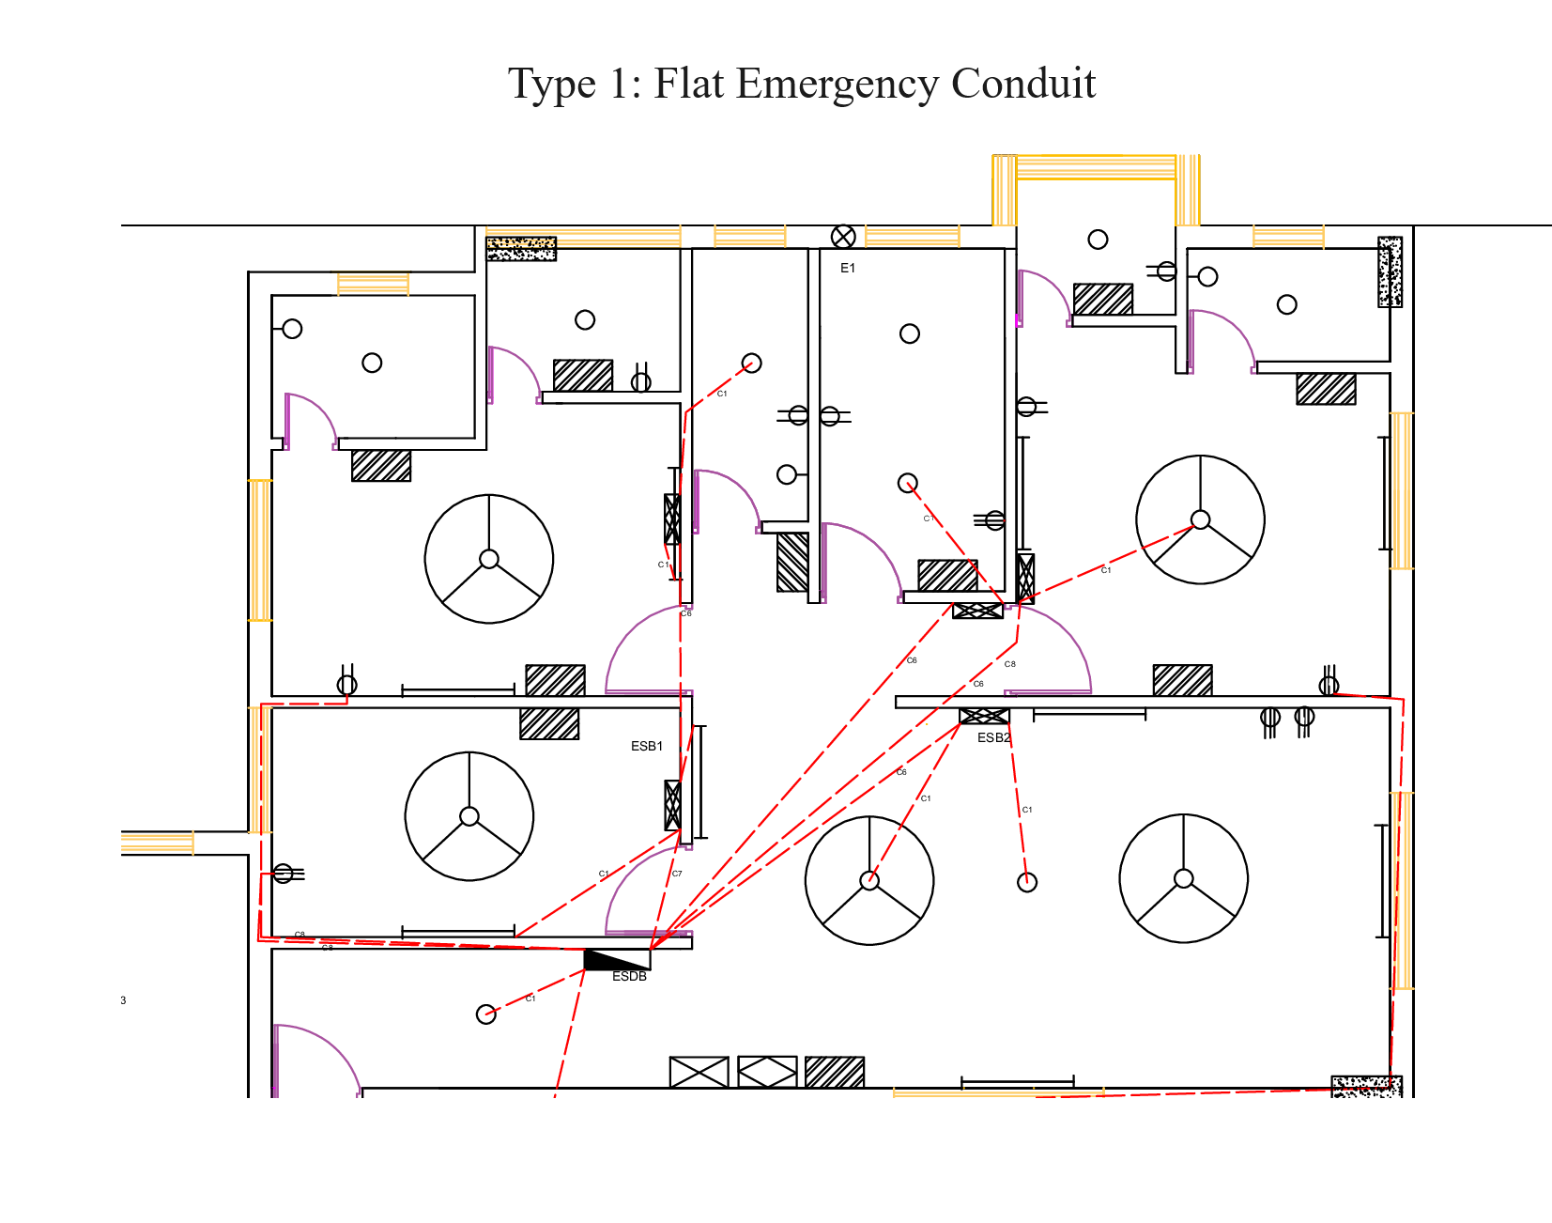

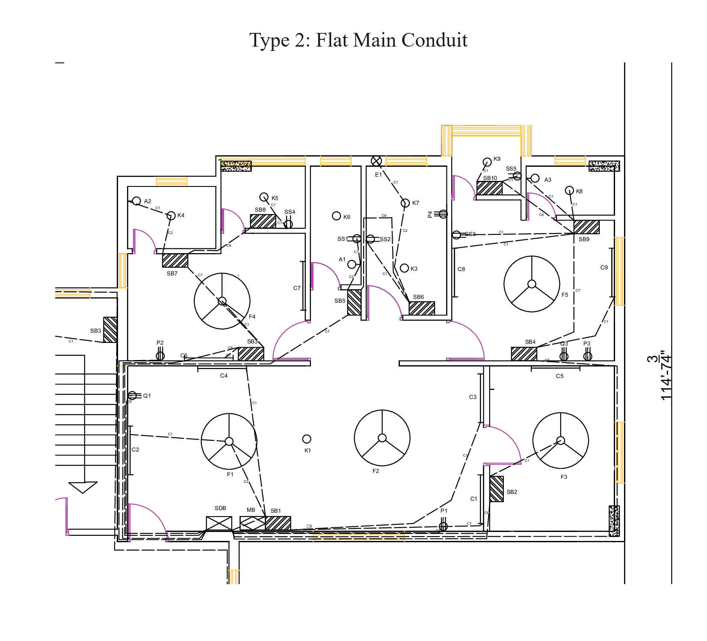

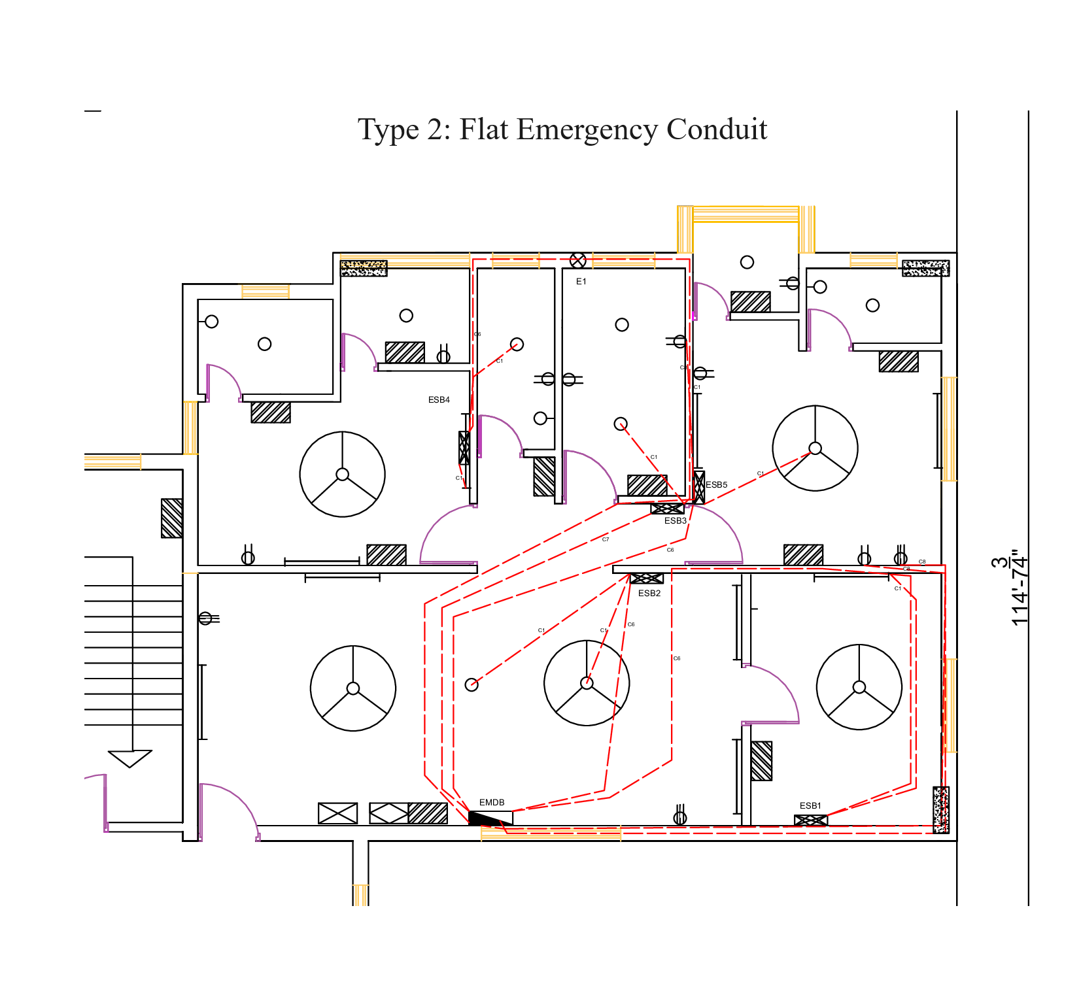

**Switch Board for Flat Type 1:**

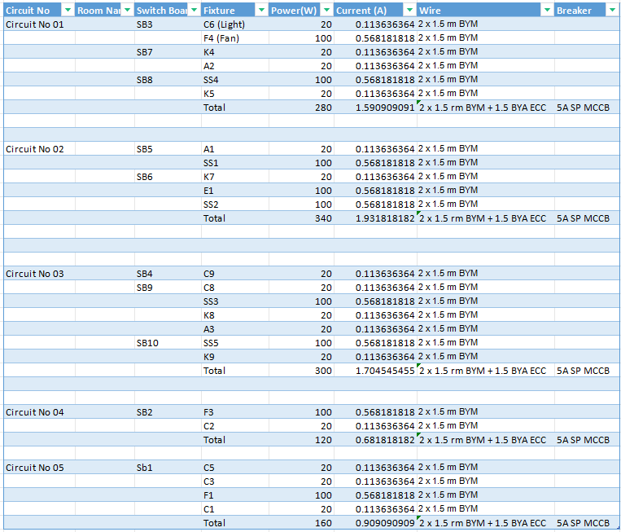

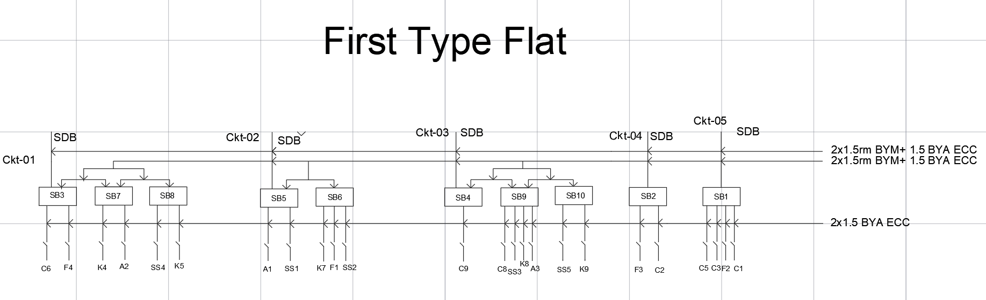

Fig:Switch Board for Flat Type 1

**Emergency Switch Board for Flat Type 1:**

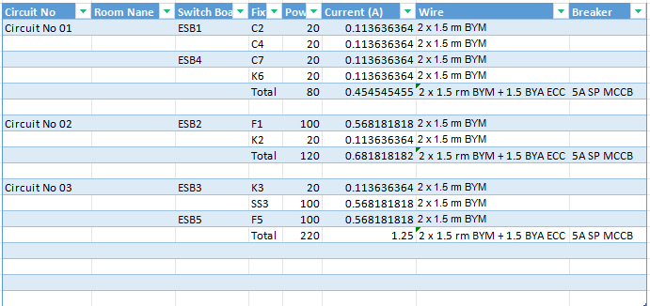

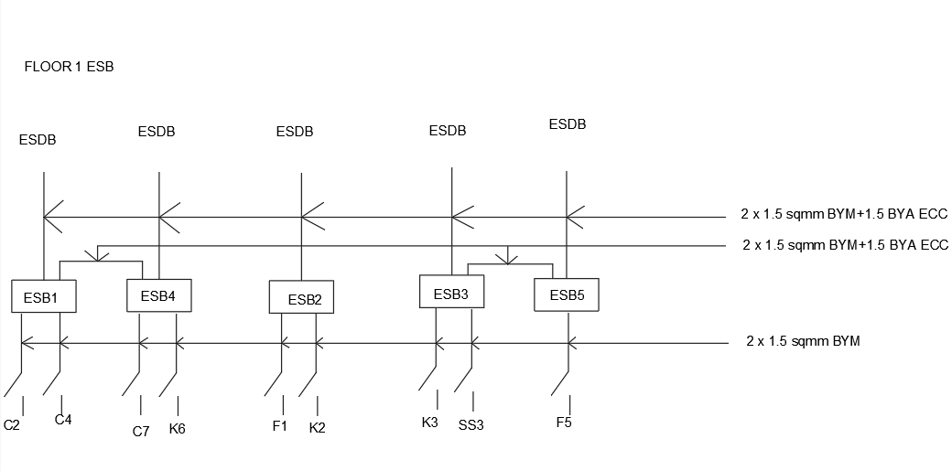

Fig:Emergency Switch Board for Flat Type 1:

**Switch Board for Flat Type 2:**

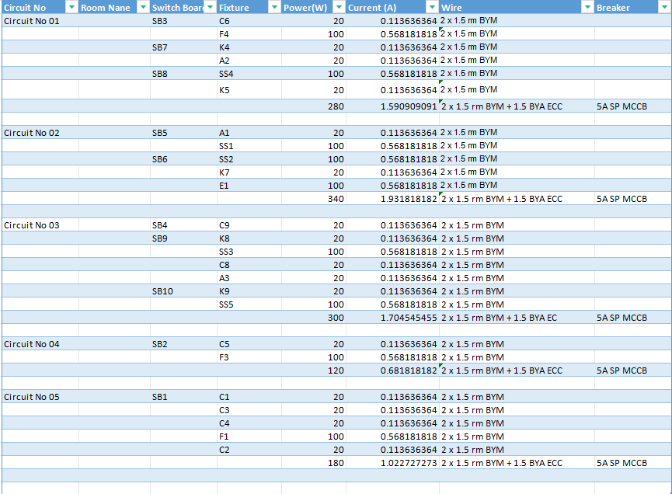

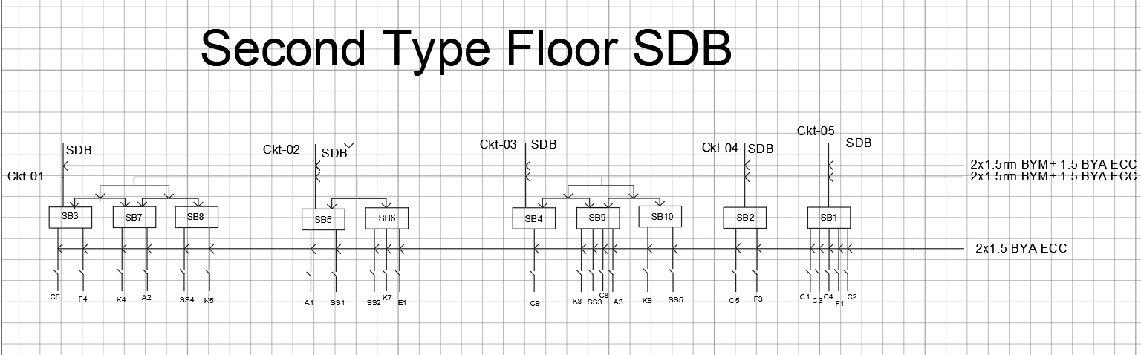

Fig:Switch Board for Flat Type 2:

**Emergency Switch Board for Flat Type 2:**

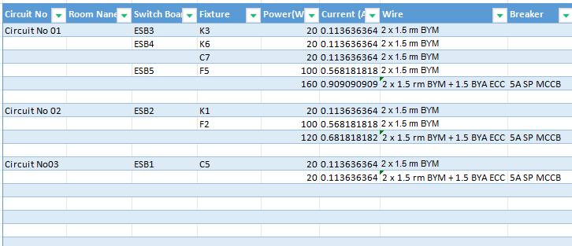

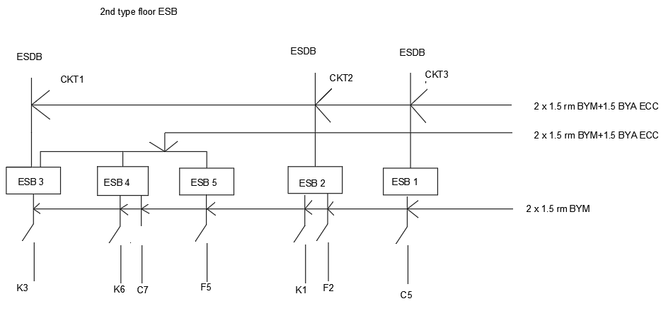

Fig:Emergency Switch Board for Flat Type

**Switch Board for Lobby:**

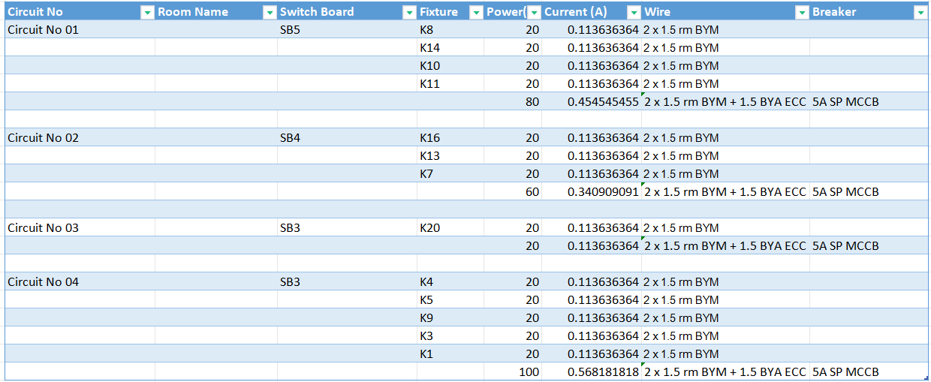

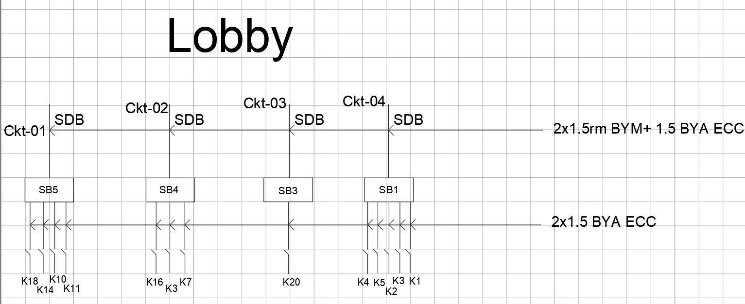

Fig:Switch Board for Lobby

**Emergency Switch Board for Lobby:**

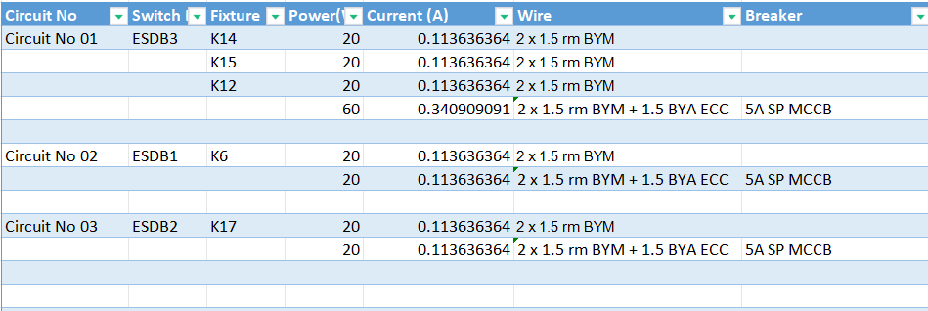

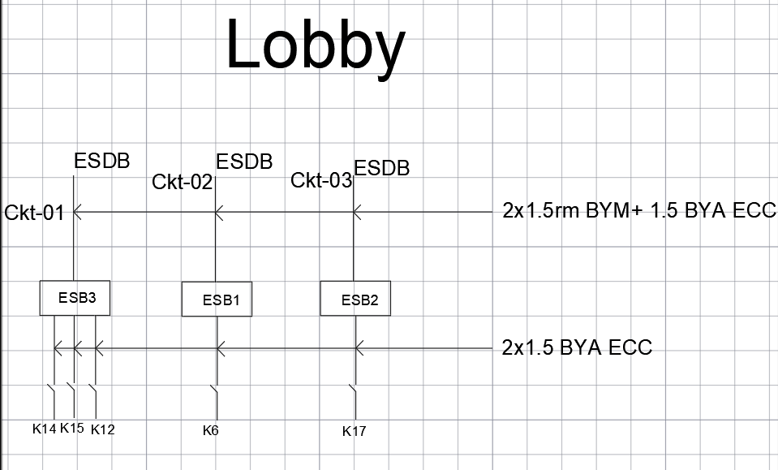

Fig:Emergency Switch Board for Lobby

**Switch Board for Ground:**

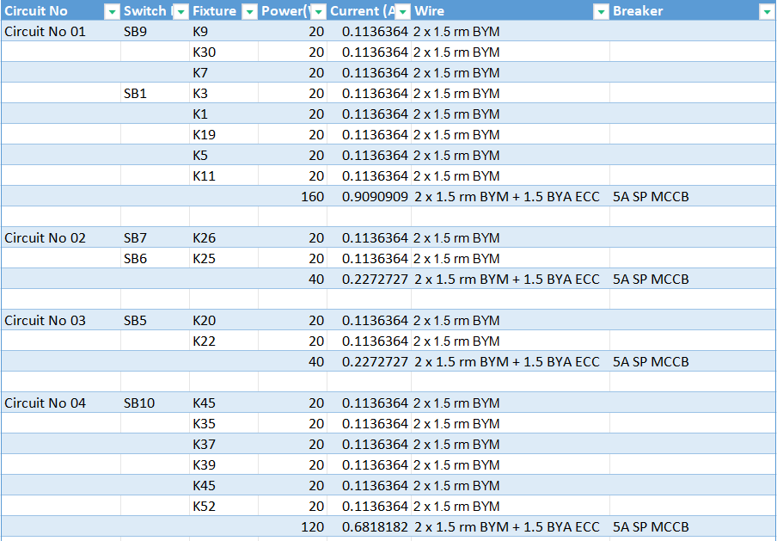

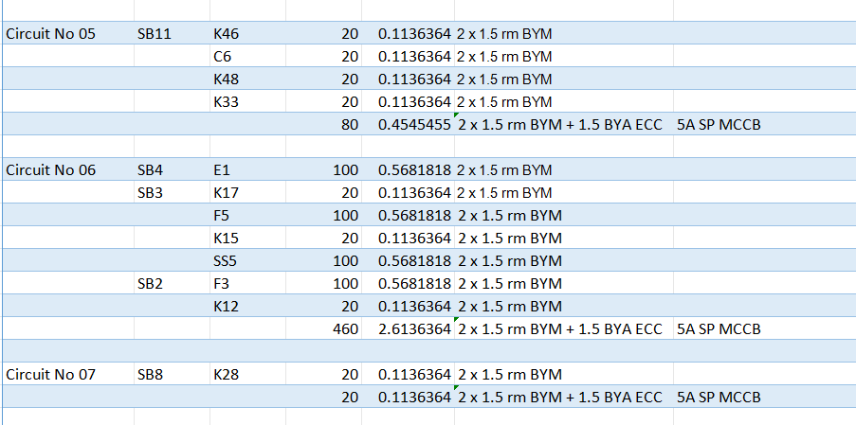

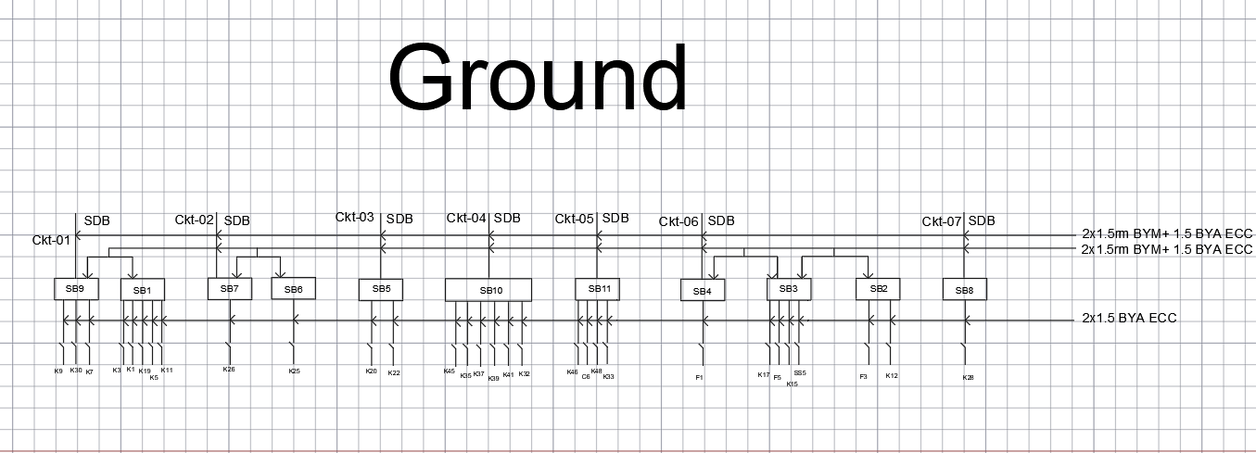

Fig:Switch Board for Ground

**Emergency Switch Board for Ground :**

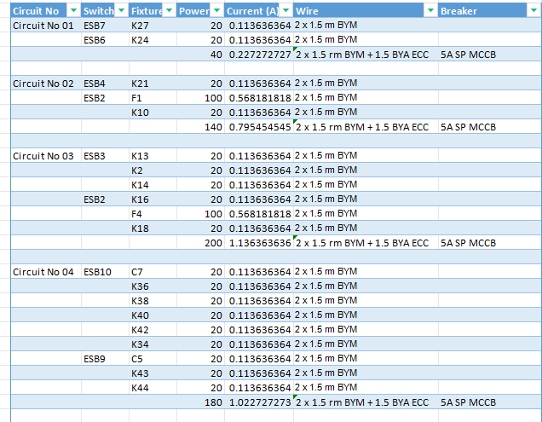

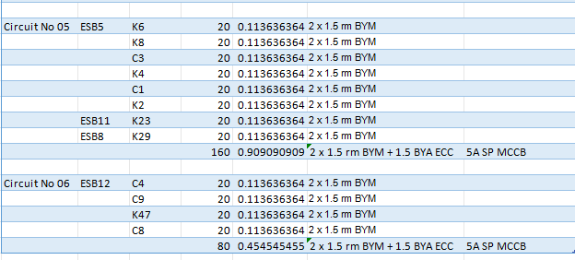

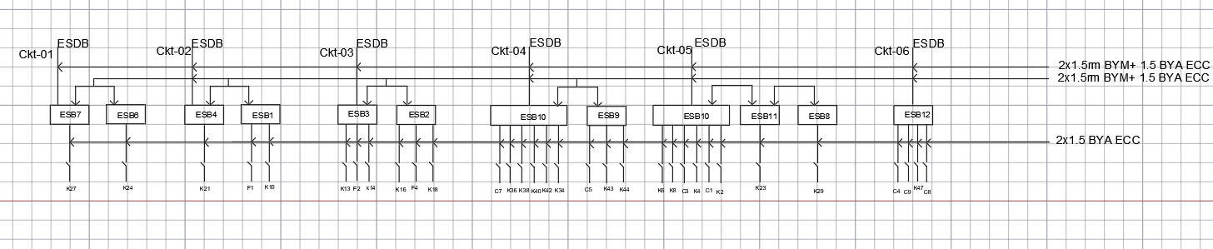

Fig:Emergency Switch Board for Ground

**Switch Board for Basement:**

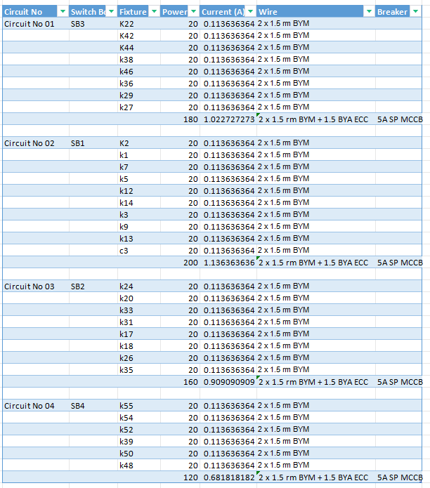

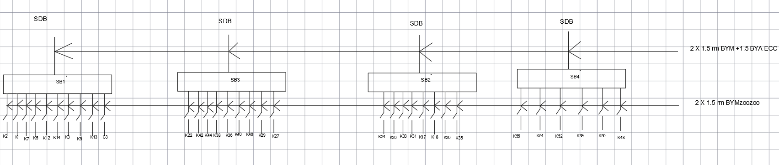

Fig:Switch Board for Basement

**Emergency Switch Board for Basement:**

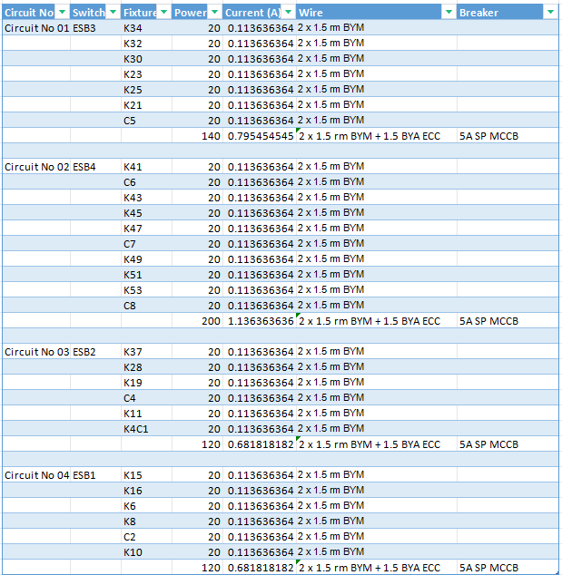

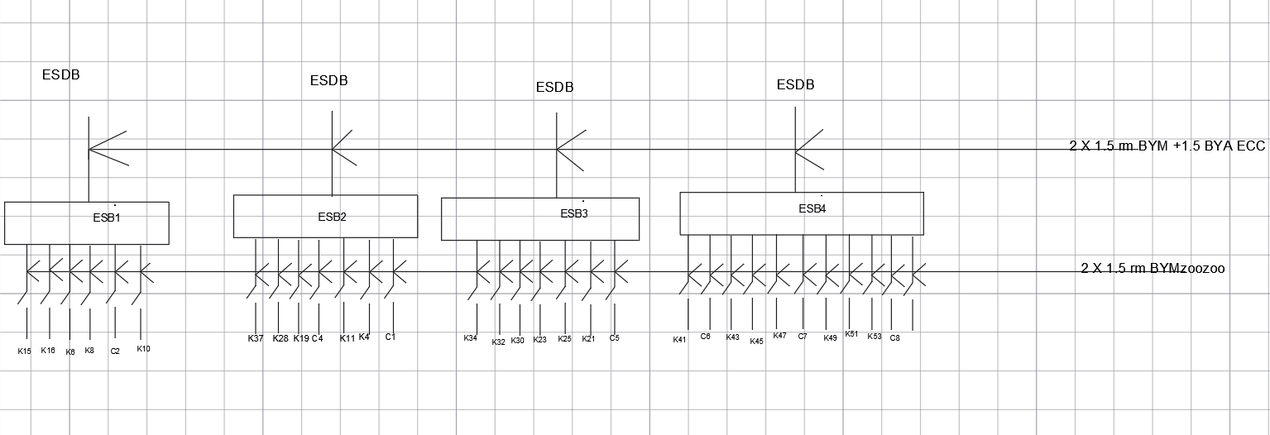

Fig:Emergency Switch Board for Basement

**Calculations for SDB (Floor Type I)**

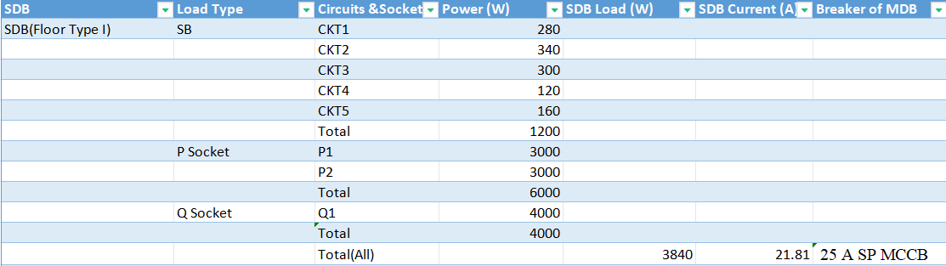

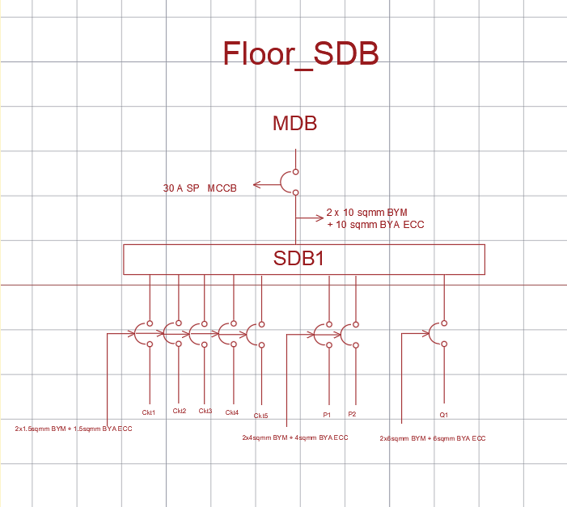

Fig:SDB of Floor type I

**Calculations for ESB (Floor Type I)**

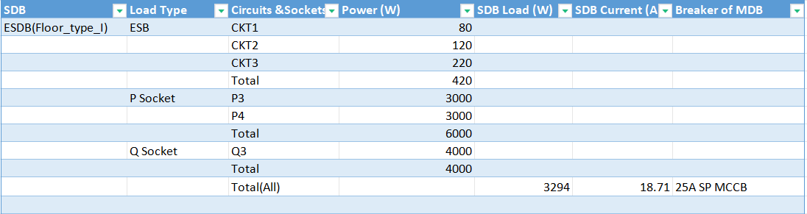

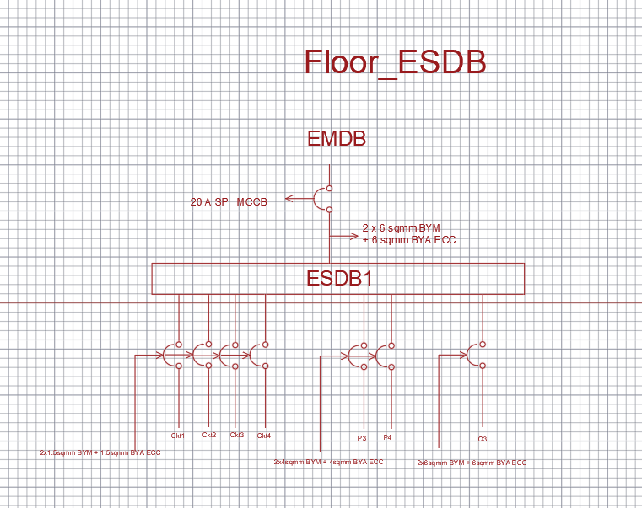

Fig:ESDB of Floor type I

**Calculations for SB (Floor Type II)**

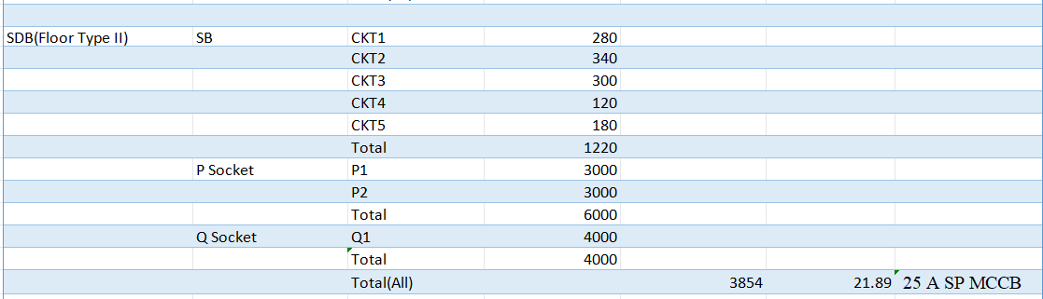



Fig:SDB of Floor type II

**Calculations for ESB (Floor Type II)**

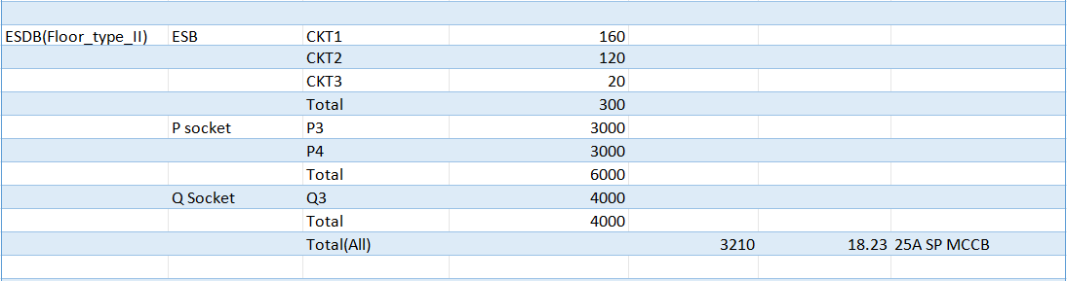



Fig:SDB of Floor type II

**Calculations for SB (Lobby)**

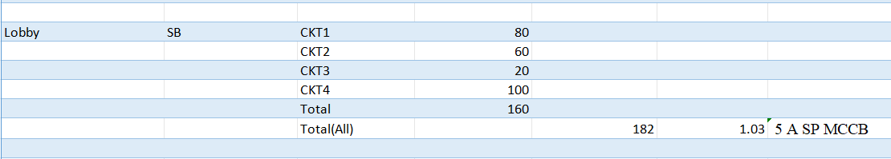

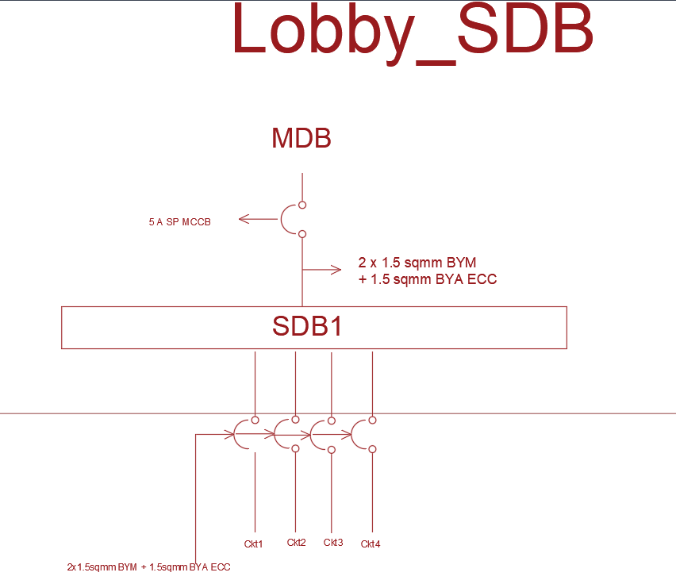

Fig:SDB of Lobby

**Calculations for ESDB (Lobby)**

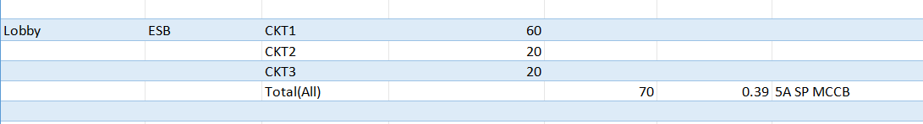

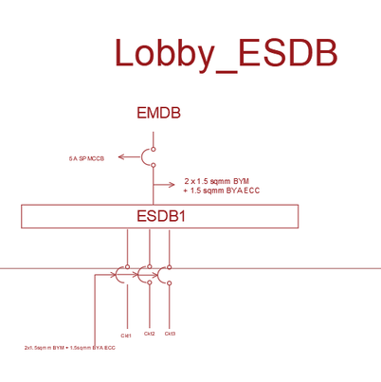

Fig:ESDB of Lobby

**Calculations for SB (Ground)**

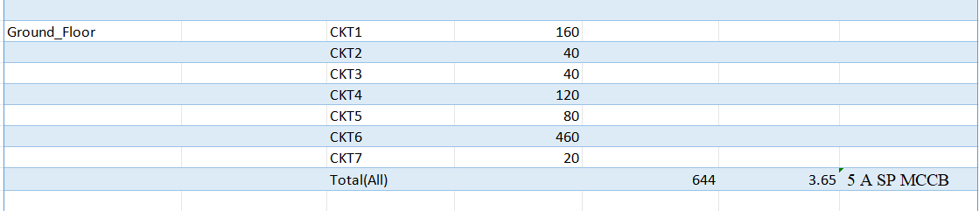

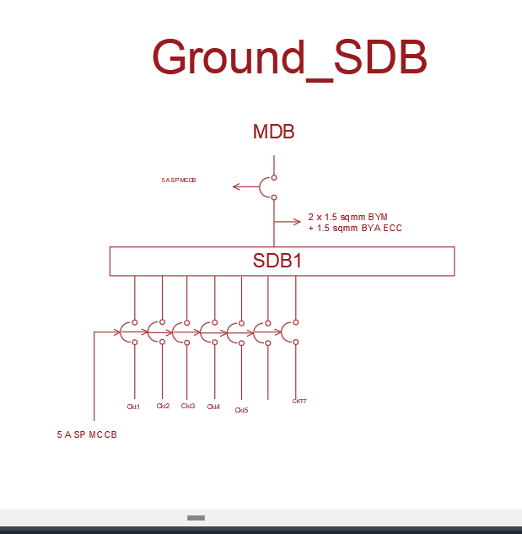

Fig:SDB of Ground

**Calculations for ESB (Ground)**

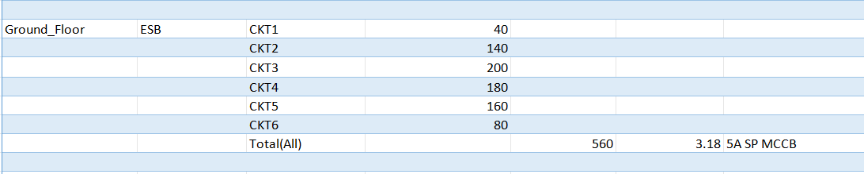

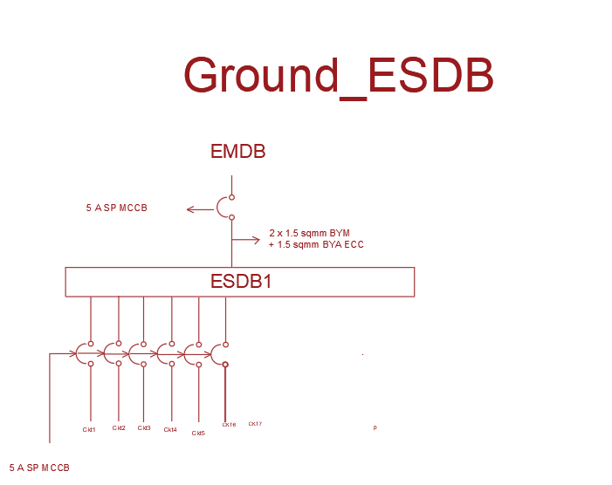

Fig:ESDB of Ground

**Calculations for SDB (Basement)**

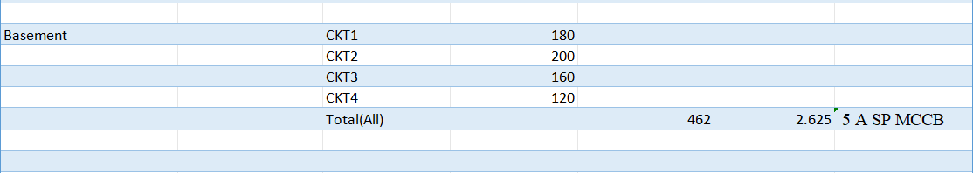

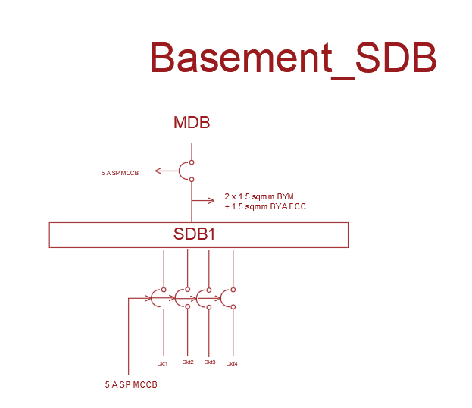

Fig:SDB of Basement

**Calculations for ESDB (Basement)**

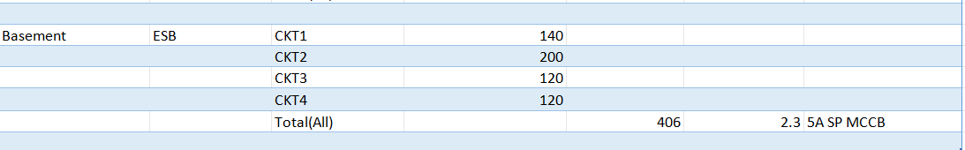

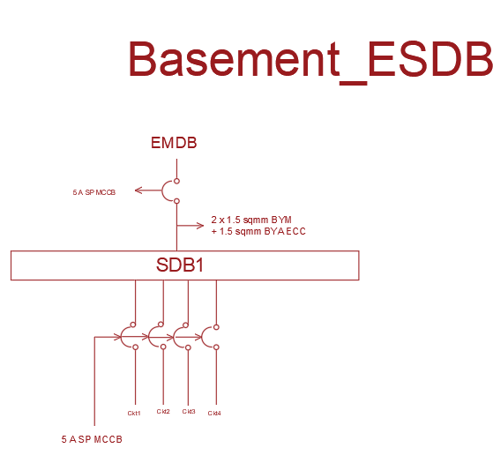

Fig:ESDB of Basement

**Calculation for EMDB:**

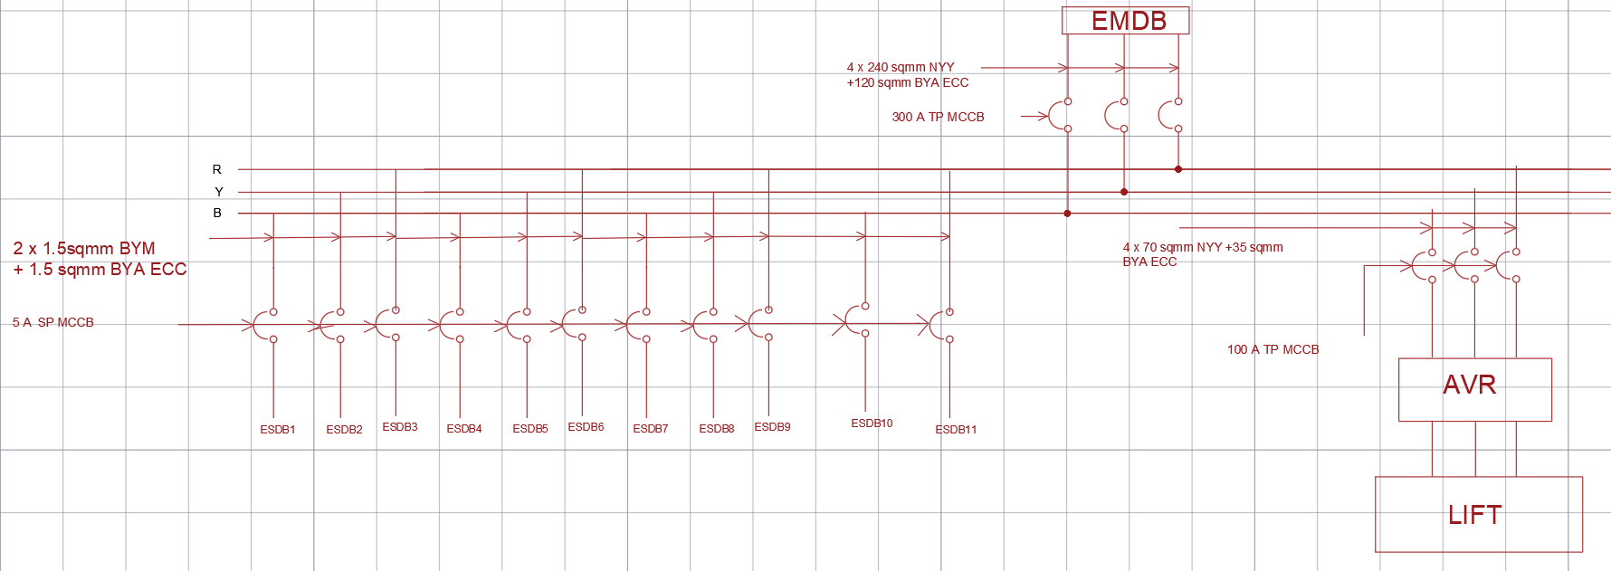

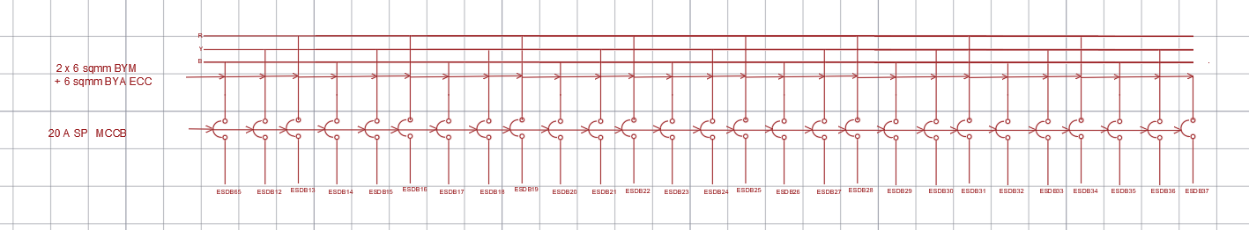

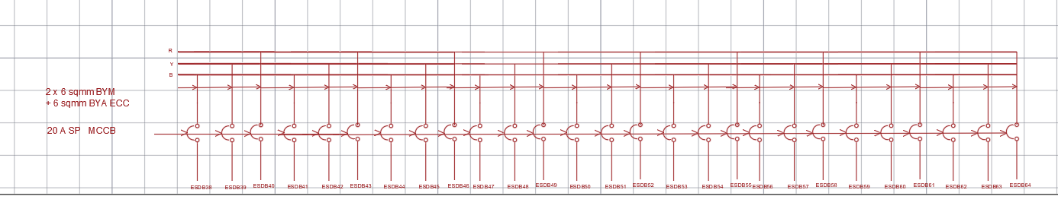

Fig:EMDB

EMDB Load = Total ESDB Load * 0.7 + Lift Load * 0.7

Total ESDB Load =9*4*ESDB(Type_1)+9*2*ESDB(Type_1) +

ESDB_Ground+ESDB_Lobby+ ESDB_Basement

EMDB Current = $\frac{EMDBLoad}{\sqrt{3}*LineVoltage*pf}$

Phase Voltage = 220 V

Line Voltage = $\sqrt{3}$* 220 = 381.05 V

Power Factor, pf = 0.8

Total ESDB Load = 9*3294*4+9*3210*2+9*70+560+406 =177960W = 177.96 kW

Lift Load =2* 18.5 kW=37kW

EMDB Load = 177960 * 0.7 + 37000 * 0.7 =150472 W = 150.472 kW

EMDB Current = $\frac{150472}{\sqrt{3}*381.05*0.8}$ =284.98 A

So300 A TP MCCB is needed from EMDB to MDB.

**(reference slide) PWD RATE SCHEDULE for Subhead Wiring and Cables 1.14.1.14 g**

Wire is 4x240 sqmm NYY +120 sqmm BYA ECC

**Generator Sizing**

EMDB LOAD =150 KW, Assumed pf = 0.75

Generator size= LOAD/pf = 150 kW/ 0.75

=200 KVA

**FROM PWD RATE SCHEDULE(Subhead-2.2 Generator & Related works )**:

200 KVA with ATS is vailable

**Lift Sizing**

**https://www.indiamart.com/proddetail/elevators-lift-drivers-delta-make-3-75-kw-to-18-75-kw-24416869530.html**

**lift load = 18.75 reference**

Lift load =37 kW assumed Pf =0.6 for current calculation

Line current = 37 KW /(aqrt(3) *381.05* 0.6 =93.4 A

Wire needed = 4* 70 NYY sqmm BYM+ 35 sqmm BYA ECC

(reference slide) PWD RATE SCHEDULE for Subhead Wiring and Cables 1.14.1.9

(Country lift BD : motor 6.2 KW+ 6.8 KW for 10 person and 1.5 m/s)

**Calculation for MDB**

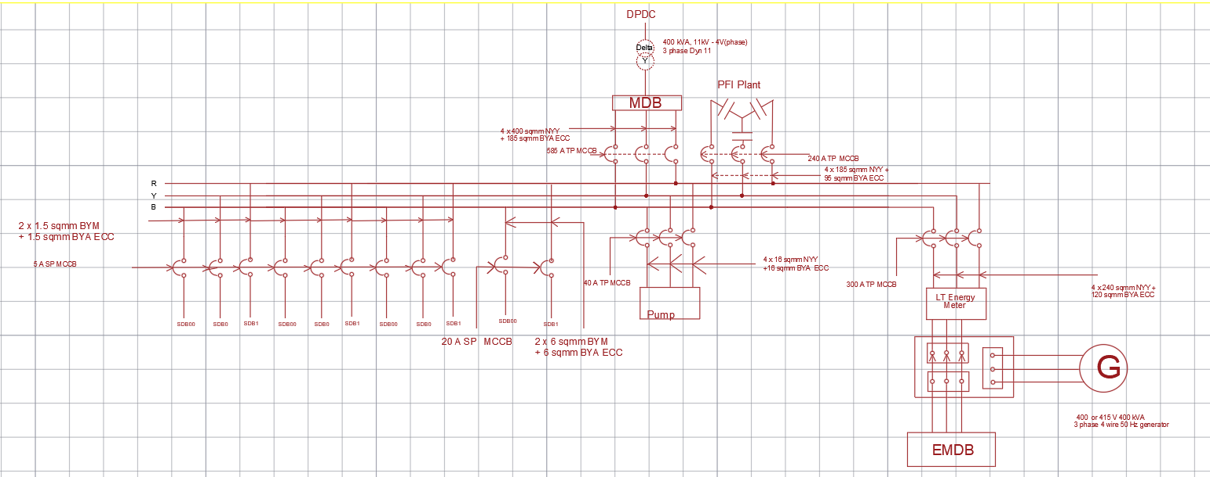

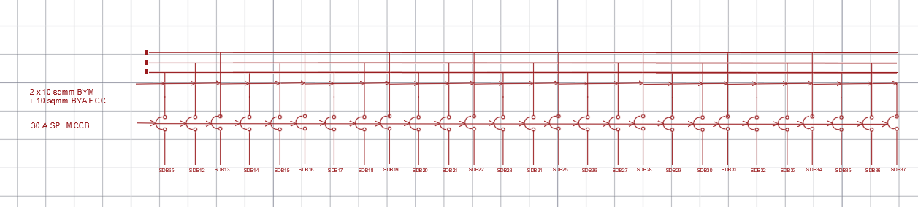

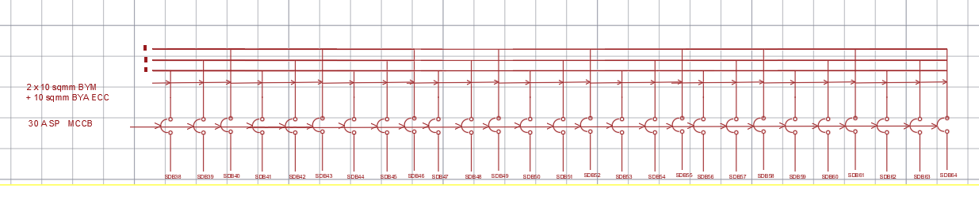

Fig:MDB

MDB Load = Total SDB Load * 0.7 + (EMDB Load + Pump Load) * 0.7

Total SDB Load = 9*4*SDB(Type_1)+9*2*SDB(Type_1) +

SDB_Ground+SDB_Lobby+ SDB_Basement

MDB Current = $\frac{MDBLoad}{\sqrt{3}*LineVoltage*pf}$

Phase Voltage = 220 V

Line Voltage = $\sqrt{3}$* 220 = 381.05 V

Power Factor, pf = 0..8

Total SDB Load = 9*3840*4+9*3854*2+9*182+644+462 =210356 W =210.356 kW

Pump Load = 15000 W

MDB Load = 210356 * 0.7 + (150472 +1 5000) * 0.7 = 263079.6 W = 263.0796 kW

MDB Current = $\frac{263079.6}{\sqrt{3}*381.05*0.8}$ = 498.25A

So, 500 A TP MCCB is needed from MDB to Main Line.

Wire : 4x 400 sqmm NYY +185 sqmm BYA ECC

(reference slide) PWD RATE SCHEDULE for Subhead Wiring and Cables 1.14.1.16

**Pump Current Calculation**

Pump power = 15000 W 3 phase ; assumed pf= 0.7

Pump Current = 15000 / ( sqrt(3)*381.05*0.7 ) = 32 A

CB : 40 A

Wire : 4 x 16 sqmm NYY +16 sqmm BYA ECC

**Calculation for Transformer**

**Total MDB LOAD**

S = sqrt(3) V I = 3 * 220 * 498.25 = 328845 KVA = 328.845 kVA

A power factor of 0.8 has been used for all SDB load

Taking an overload factor of 0.8

required Transformer = 328.845 KVA/ 0.8 = 411 KVA

So, 11/0.415 kV, 50 Hz, 400 kVA, DYN 11, Oil Immersed Transformer with 4-6% Impedance is needed.

(reference ) PWD RATE SCHEDULE 2.1.4.7

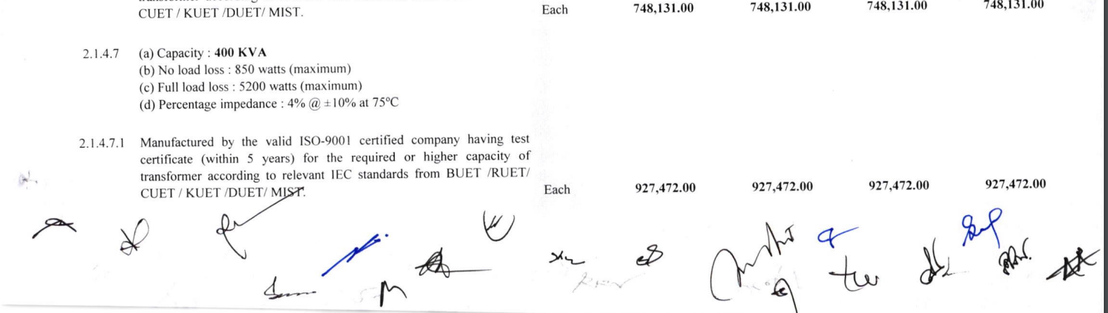

**Calculations For PFI Plant:**

Q=PtanѲ=263079.6*tan(36.86)=197.2381 kvar

Desired power factor=0.95

So PFI plant of 150 KVAR is needed. Then power factor will be : cos (arctan (47,238/263079) )= 0.985

###### I=Q/(3V)=150 kVAR/(3*220)=228 A

CB : 250 A

Wire : 4 x 185 sqmm NYY + 95 sqmm BYA ECC

**Riser:**

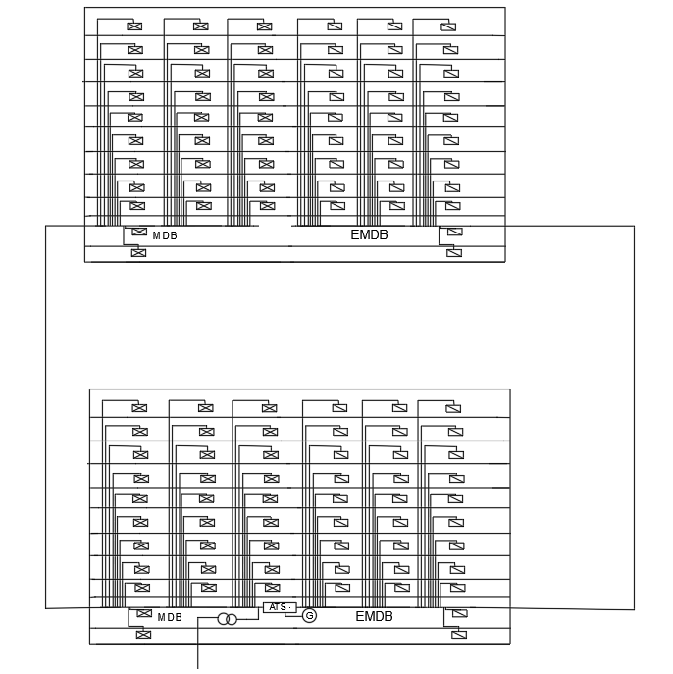

Fig:Riser

**Lightning Protection:**

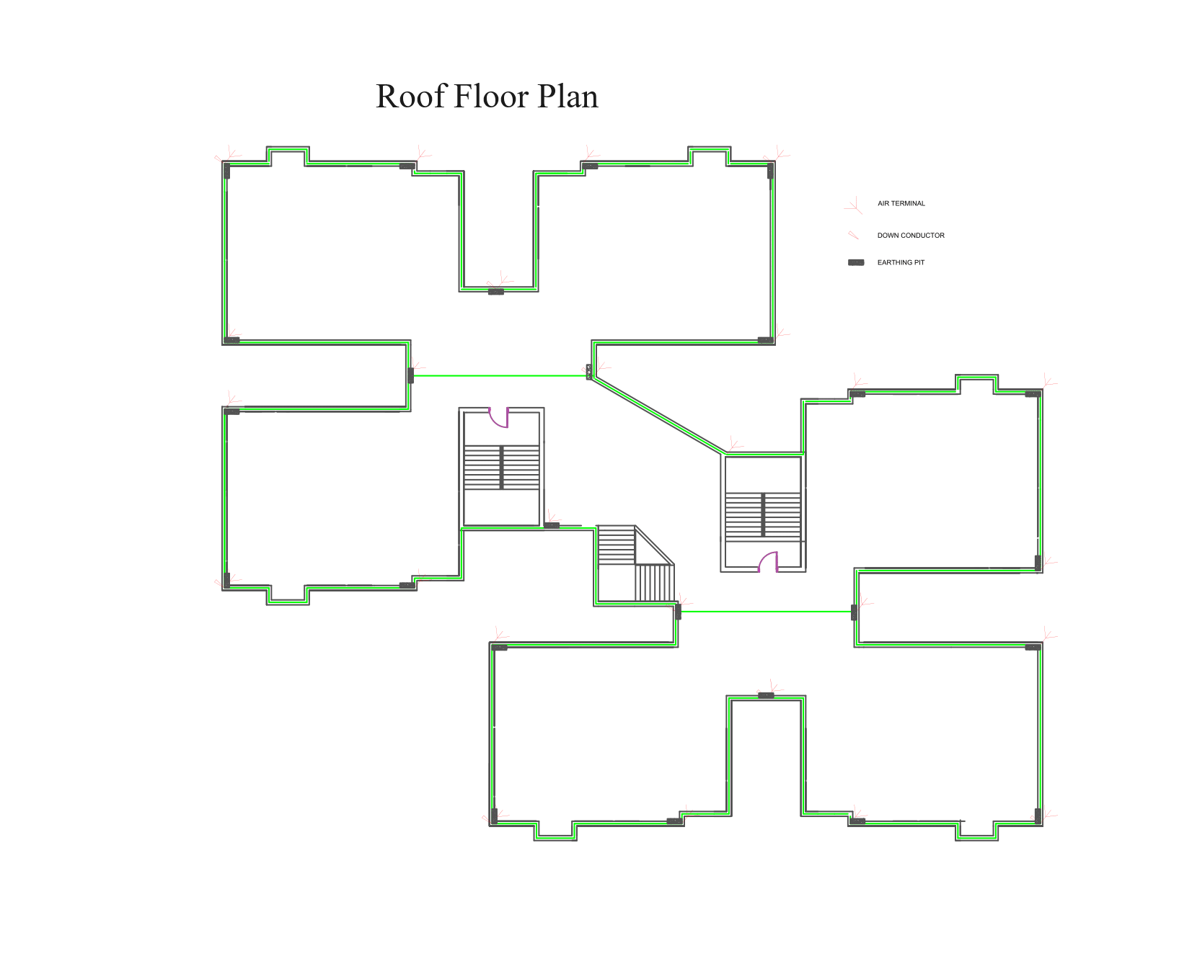

**Risk Assessment**

|  |  |  |  |
| --- | --- | --- | --- |
| **Index** | **Parameter** | **Class** | **Value** |
| A | Use of Structure | Houses and similar buildings | 2 |
| B | Type of Construction | Reinforced concrete with nonmetal roof | 3 |
| C | Contents of Consequential Effects | Ordinary domestic of office building, factories and workshops not containing valuable materials | 2 |
| D | Degree of Isolation | Located in a large area having structures of similar or greater height | 2 |
| E | Type of Terrain | Flat terrain at any level | 2 |
| F | Height of Structure | 30-38 m | 16 |
| G | Lightning Prevalence | Over 21 | 21 |
| Total |  |  | 48 |

Risk assessment factor > 40, lightning protection system is mandatory but can be used for increased safety.

The lightning protection system that was designed here has

**Calculations for air terminals:**

In this case, the rolling sphere method has been used to determine the maximum distance between adjacent air terminals or air spikes.

$d=\sqrt{h(2R-h^{2})}$

Where, d = horizontal protected distance

h = height of the air terminal

R = radius of the rolling sphere.

According to NFPA 780, the air terminal should have a minimum height of 10 inches. For a 24-inch air terminal, a support measuring 12 inches should be used, as the support length should not be less than half of the air terminal's length.

Thus, we are using R = 30 m and h = 24 inches

We get, d = 6.02 m, and so distance between two air terminals can be maximum 12.04 m or 39.501312 ft.

Our rooftop is a flat roof with an irregular perimeter, so we have used the roof edge of the irregular shapes to locate the air terminals. Because of the irregular shape, adjacent air terminals have been placed at varying distances of 23 ft, 24 ft 8 inches, 25 ft, 26 ft 10 inches, 31 ft and 32 ft.

**Calculations for down conductors:**

Total area of the rooftop = area of lobby + ( area of each flat X 6 ) + area of all staircases

= 173.5528 sq. m + ( 111.138163 * 6 ) sq. m + 68.305 sq. m

= 908.686778 sq. m

There shall be one down conductor for the first 80 $m^{2}$ plus a further one for every 100 $m^{2}$.

Thus, there will be 1 down conductor for the first 80 $m^{2}$ and then for the remaining area, there will be (908.686778-80)/100 = 8.2868 =~ 9 down conductors. So, there will be a total of 10 down conductors.

We placed these down conductors with the air terminals.

**Earthing pits:**

Earthing pits were provided with each air terminal.